Vehicle Management System Using Salesforce

**NAAN MUDHALVAN PROJECT REPORT**

***Submitted by***

**KAMALI S (620120104042)**

**HARINI S (620120104030)**

**DEVASRI A Y (620120104019) GOKULAPRIYA K (620120104026)**

***in partial fulfilment for the award of the degree of***

# BACHELOR OF ENGINEERING

***in***

# COMPUTER SCIENCE AND ENGINEERING

**AVS ENGINEERING COLLEGE,**

**SALEM – 636003.**

# ANNA UNIVERSITY::CHENNAI 600025

**BONAFIDE CERTIFICATE**

Certified that this the project report titled **“Build A Vehical Management System using Salesforce”** is the bonafide work of **“KAMALI S (620120104042), HARINI S (620120104030), DEVASRI A Y (620120104019) ,GOKULAPRIYA K (620120104026)”**

who carried out the project work under my supervision.

## SIGNATURE

**Prof.G.AROKIYANATHAN.**

**ME.,ASSISTANTPROFESSOR**

**FACULTY MENTOR**

Department of Computer Science and Engineering

AVS Engineering College, Ammapet,

Salem – 636003.

## SIGNATURE

**Dr.R. KARTHIKEYAN M.E., Ph.D.,**

**ASSISTANT PROFESSOR**

## SPOC FACULTY

Department of Computer Science and Engineering,

AVS Engineering College,

Ammapet,

Salem – 636003.

## SPOC HEAD OF THE DEPARTMENT

**ACKNOWLEDGEMENT**

We would like to express our gratitude and appreciation to all those who gave us the possibility to complete this report. We would like to acknowledge with much appreciation to our honorable Chairman, **Shri.K.KAILASAM**. Secretary, **Shri. K.RAJAVINAYAKAM**, **MBA**. and also, to our Correspondent, **Shri. K.SENTHIL KUMAR, B.Tech** for providing all necessary facilities for the successful completion of the project.

We have immense pleasure in expressing our gratitude to our beloved Principal, **Dr. A. SRINIVASAN, M.E, Ph.D.,** for allowing us to have extensive use of our college facilities to do this project. It gives us a great sense of pleasure in expressing our gratefulness to our beloved Vice Principal's, **Dr. R. VISWANATHAN, M.E.,** **Ph.D.,** and **Dr. D.R. JOSHUA, M.E., Ph.D.,**

for their professional guidance in scheduling the project work to complete ontime.

We express our heartiest gratitude to **Dr. M. VILASINI M.E, Ph.D**., Dean R&D and Head of the Department **Prof. V. MEENA, M.E**., Computer Science and Engineering, for her guidance and encouragement throughout the Project Period. Also, we express our sincere and heartiest gratitude to class advisor and project coordinator **Prof. S. PRIYADHARSHINI, M.E.,** Assistunt Professor and guide **Prof. S.. AROKIYANATHAN, M.E.,** Assistant Professor for their constant helps and creative ideas over the period of project work.

We specially thank all our Teaching and Non-Teaching Staff Members andLab Technicians of the Department of Computer Science and Engineering fortheir consistent encouragement to do the project work with full interest and zeal. We pay our profound gratitude to God for his invisible vigilance and would like to thank our Parents for giving us support, encouragement and guidance throughout the course of our work.

**TABLE OF CONTENTS**

|  |  |  |
| --- | --- | --- |
| **Chapter No** | **Title** | **Page No** |
|  | **LIST OF FIGURES** | **5** |
|  | **LIST OF ABBREVIATION** | **6** |
| **1.** | **PROJECT SPECIFICATION** | **7** |
|  | 1.1 Project Goal | 7 |
|  | 1.2 Project Scope | 8 |
|  | 1.3 Problem Statement Definition | 9 |
|  | 1.4 Empathy Map Canvas | 10 |
|  | 1.5 Ideation & Brainstorming | 11 |
|  | 1.6 Proposed Solution | 14 |
|  | 1.7 Functional & Technical Requirements | 16 |
|  | 1.8 Project Road Map | 19 |
| **2** | **PREPARATION DATA MODELING** | **23** |
|  | 2.1 Salesforce Developer Org | 23 |
|  | 2.2 Custom Object Creation & Tabs | 25 |
|  | 2.3 Lightning App | 29 |
|  | 2.4 Relationship between Objects | 31 |
|  | 2.5 Customize User Interface | 33 |
|  | 2.6 Business Logic | 37 |
| **3.** | **Users & Data Security** | **38** |
|  | 3.1 User Creation & Setup Approvals | 38 |
| **4.** | **Automation** | **40** |
|  | 4.1 Flow | 40 |
|  | 4.2 Approval Process | 42 |
| **5.** | **Reports & Dashboard** | **48** |
|  | 5.1 Reports | 48 |
|  | 5.2 Dashboard | 50 |
| **6.** | **Conclusion** | **51** |
| **7.** | **Project Demonstration** | **52** |
|  | Github & Project Video Demo Link | 52 |

# LIST OF FIGURES

|  |  |  |
| --- | --- | --- |
| **Figure No** | **Name Of Figure** | **Page No** |
| 1.8.1 | Data Flow Diagram | 19 |
| 1.8.2 | Technical Architecture | 20 |

**LIST OF ABBREVIATION**

|  |  |
| --- | --- |
| CRM | Customer Relationship Management |
| ESP | Email Service Provider |
| UI | User Interface |
| UX | User Experience |
| OWD | Org - Wide Default |
| CTA | Call To Action |
| CSV | Comma - Separated Values |
| SLA | Service Level Agreement |
| API | Application Programming Interface |
| SaaS | Software as a Service |
| PaaS | Platform as a Service |

# CHAPTER-1 PROJECT SPECIFICATION

* 1. **Project Goal**

Building an Employee Travel Approval Application for corporate use within the Salesforce platform involves a multi-faceted approach, starting with requirements gathering to define user roles and workflows. A well-structured data model captures essential information, and user-friendly interfaces for both employees and managers streamline the travel request and approval process. Workflow automation facilitates efficient routing and notifications, while integrations with external systems like expense management tools enhance data accuracy.

Robust reporting and analytics tools offer insights, and mobile app development ensures accessibility on-the-go. Security and compliance measures safeguard sensitive data, and thorough testing ensures a reliable application. Training and documentation support user adoption, and ongoing maintenance and improvements address evolving needs. Scalability planning and future enhancements cater to growing demands, while comprehensive documentation maintains transparency, ultimately streamlining the travel approval process and enhancing efficiency.

# Project Scope

The Employee Travel Approval Application built in Salesforce serves a vital purpose in corporate travel management. Firstly, it streamlines and automates the often complex and time-consuming travel request and approval process. This efficiency results in reduced administrative burdens, faster approval times, and improved communication between employees and managers. With the ability to centralize all travel-related data, the application ensures data accuracy and compliance with corporate policies and regulatory requirements, contributing to better financial management and accountability.

The application fosters transparency throughout the travel approval workflow. Both employees and managers can easily track the status of travel requests, which enhances visibility into the process. By providing a clear overview of approval progress, it minimizes potential delays and miscommunication, ultimately improving the user experience and helping employees plan their travel more effectively.

The Employee Travel Approval Application in Salesforce offers robust security, ensuring that sensitive data is protected while also providing scalability for future growth. The built-in reporting and analytics tools offer insights into travel expenses and approval metrics, supporting data-driven decision-making. By facilitating on-the-go access through mobile app development, the application empowers employees and managers to manage travel efficiently and enhances the organization's overall travel management capabilities. In conclusion, the application optimizes corporate travel management by enhancing efficiency, transparency, and control, ultimately leading to cost savings and a more seamless user experience.

# Problem Statement Definition

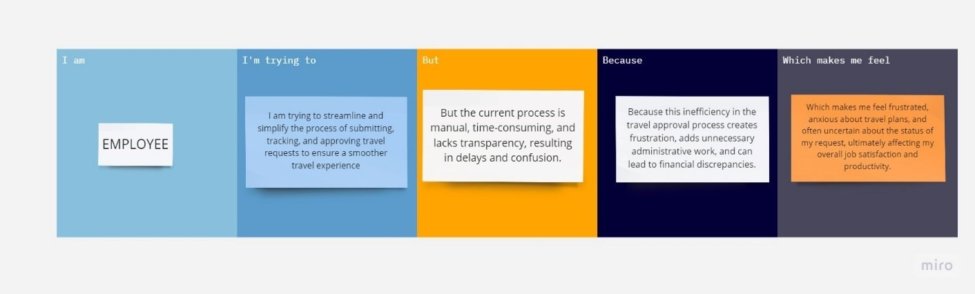

|  |  |  |  |  |  |
| --- | --- | --- | --- | --- | --- |
| **Problem Statement (PS)** | **I am (Employee)** | **I’m trying to** | **But** | **Because** | **Which makes me feel** |
| PS | Employee | I am trying to streamline and simplify the process of submitting, tracking, and approving travel requests to ensure a smoother travel experience | But the current process is manual, time- consuming, and lacks transparency  , resulting in delays and confusion. | Because this inefficiency in the travel approval process creates frustration, adds unnecessary administrative work, and can lead to financial discrepancies | Which makes me feel frustrated, anxious about travel plans, and often uncertain about the status of my request, ultimately affecting my overall job satisfaction and productivity |

* 1. **Empathy Map Canvas**

An empathy map is a simple, easy-to-digest visual that captures knowledge about a

user’s behavior and attitudes.

It is a useful tool to helps teams better understand their users. Creating an effective solution requires understanding the true problem and the person who is experiencing it. The exercise of creating the map helps participants consider things from the user’s perspective along with his or her goals and challenges.

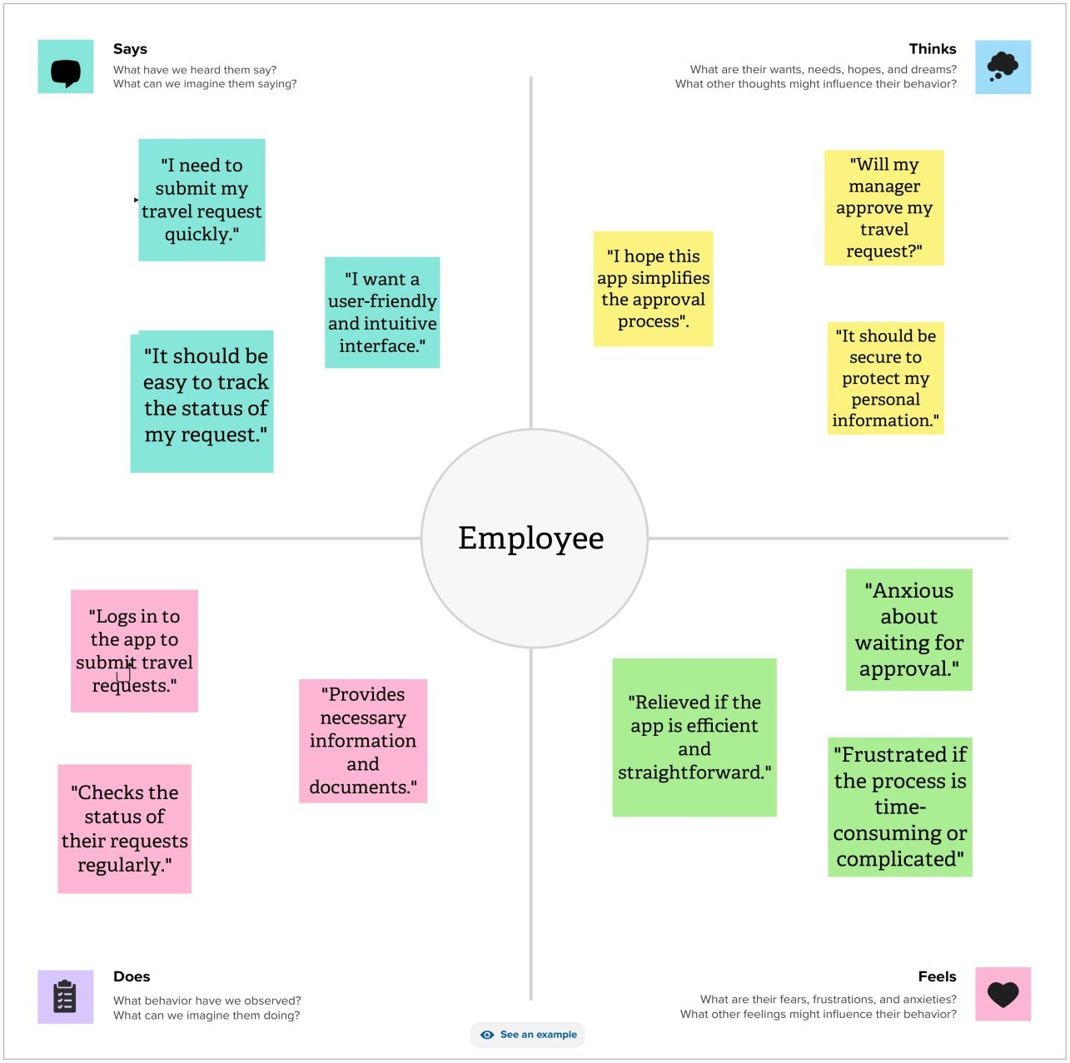

# Ideation & Brainstorming

Brainstorming provides a free and open environment that encourages everyone within a team to participate in the creative thinking process that leads to problem solving.

Prioritizing volume over value, out-of-the-box ideas are welcome and built upon, and all participants are encouraged to collaborate, helping each other develop a rich amount of creative solutions.

## Step-1: Team Gathering, Collaboration and Select the Problem Statement:

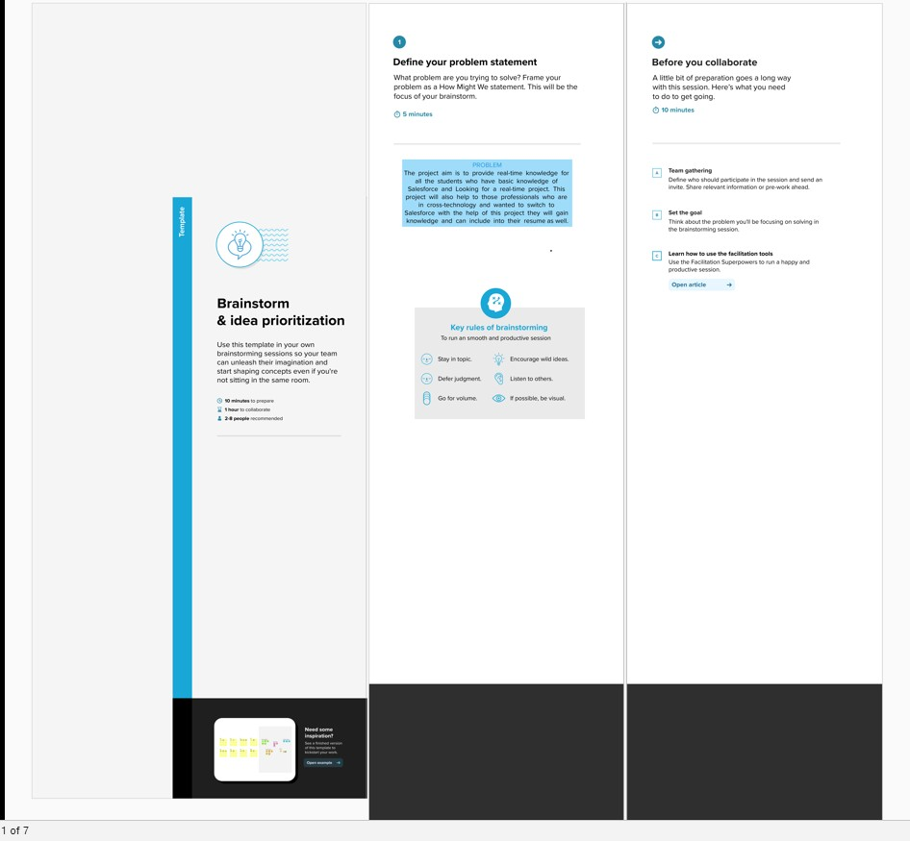

**Step-2: Brainstorm, Idea Listing and Grouping:**

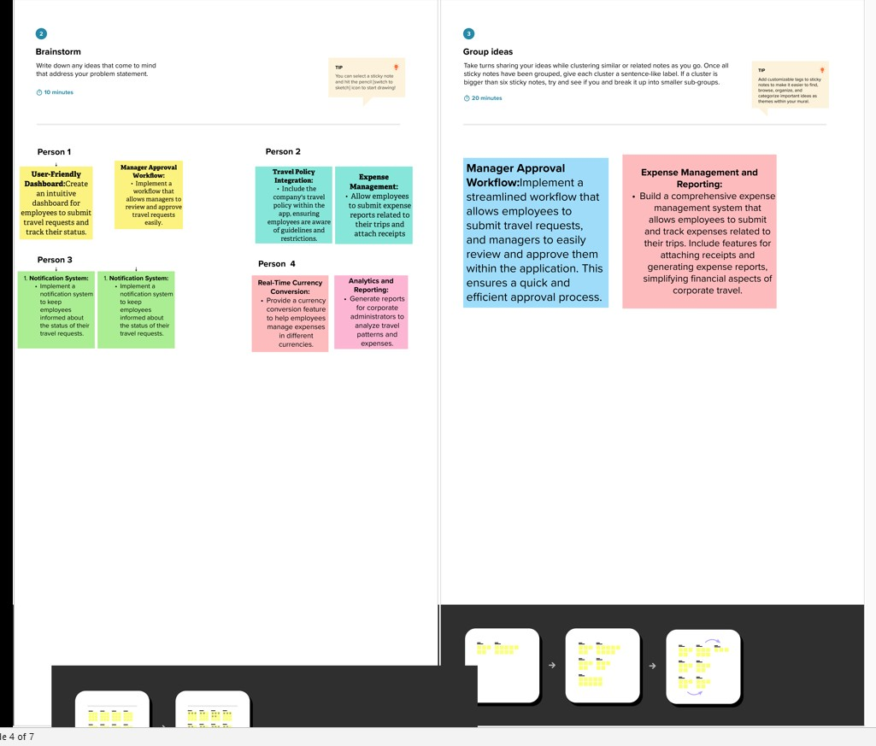

**Step-3: Idea Prioritization:**

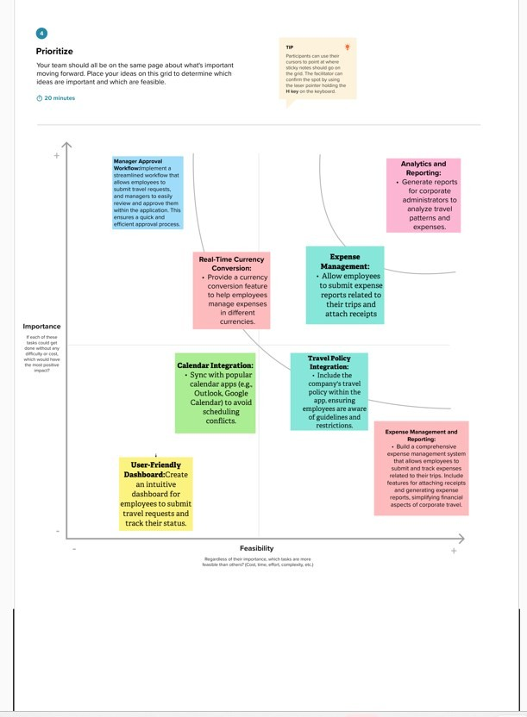

# Proposed Solution

|  |  |  |
| --- | --- | --- |
| **S. No** | **Parameter** | **Description** |
| 1. | Problem Statement (Problem to be solved) | Corporates often grapple with inefficient and manual travel approval processes that involve paperwork and a lack of transparency. These outdated methods lead to delays, increased administrative work, and potential compliance issues. The process is a source of stress for employees who require timely approvals to plan their business trips effectively, and it leaves them dissatisfied with the process.  Managers, on the other hand, struggle to review and manage a high volume of travel requests while ensuring compliance. The absence of transparency leads to bottlenecks and a lack of visibility, leaving them  overwhelmed and frustrated. |
| 2. | Idea / Solution description | Our proposed solution is to develop an Employee Travel Approval Application within Salesforce, offering automation and centralization. The application will provide a user-friendly and automated system that allows employees to submit travel requests seamlessly. Managers will be able to review and approve them efficiently, while the system offers real-time tracking of request statuses. It will also include integration with external systems for expense management, robust security measures, mobile accessibility and analytics tools for data-driven decision- making. The benefits include reduced administrative burdens, improved communication, cost control, and better compliance with corporate policies and  regulations. |

|  |  |  |
| --- | --- | --- |
| 3. | Novelty / Uniqueness | What sets our solution apart is the innovative use of Salesforce, a highly customizable and powerful platform, to streamline corporate travel management. The automation of approval workflows and integration with external systems will significantly reduce manual work and errors. The mobile app component will provide users with the flexibility and convenience of on-the-go access. Furthermore, the incorporation of robust reporting and analytics tools will enable data-driven decision-making and offer insights into travel expenses, setting our  solution apart from conventional methods. |
| 4. | Social Impact / Customer Satisfaction | Our application will have a substantial social impact by enhancing the user experience in corporate travel management. Employees and managers will benefit from a smoother, more transparent, and efficient travel approval process, reducing frustration and uncertainty. The streamlined process will free up time and resources for more strategic tasks, thereby improving overall workforce productivity.  Data-driven decision-making will lead to better cost management, making it easier to control expenses and ensuring financial compliance. The application will also guarantee compliance with corporate policies and regulatory requirements, reducing risks and ensuring data security. Lastly, by optimizing travel planning, our solution can contribute to a more sustainable approach to business travel, aligning with corporate  sustainability goals. |

* 1. **Functional & Technical Requirements**

## Functional Requirements

|  |  |  |
| --- | --- | --- |
| **FR**  **No.** | **Functional Requirement**  **(Epic)** | **Sub Requirement (Story / Sub-Task)** |
| FR-1 | User Management | **User Registration:** Allow employees to register and log into the system.  **User Roles:** Define roles (employees, managers, travel administrators) with different permissions. **User Profiles:** Capture and manage user profiles,  including contact details. |
| FR-2 | Travel Request Submission | **Travel Request Form:** Provide an intuitive form for employees to submit travel requests.  **Expense Entry:** Allow users to enter estimated expenses, including flights, accommodation, meals, and incidentals.  **Travel Dates:** Specify departure and return dates, including the option for flexible schedules.  **Attachments:** Enable the attachment of supporting documents, such as itineraries or conference detail |
| FR-3 | Approval workflow | **Workflow Automation:** Implement an automated approval process with defined workflows.  **Manager Assignment:** Automatically route requests to the appropriate manager based on criteria like department or project.  **Notifications:** Send notifications to managers and employees at various stages of the approval process. **Delegation**: Allow managers to delegate their  approval authority when they are unavailable. |
| FR-4 | Approval Management | **Manager Dashboard**: Provide managers with a dashboard to view and manage pending travel requests.  **Request Review:** Allow managers to review travel details, expense estimates, and supporting documents.  **Approval/Rejection:** Enable managers to approve or reject requests with comments.  **Escalation:** Implement escalation processes for  unattended requests or those exceeding certain thresholds |

|  |  |  |  |
| --- | --- | --- | --- |
| FR-5 | Expense Tracking | **Expense Tracking:** Record actual expenses incurred during the trip.  **Receipt Upload:** Allow users to upload expense receipts for verification.  **Expense Categories:** Categorize expenses (e.g., transportation, lodging, meals) for reporting.  **Expense Reconciliation:** Compare estimated and  actual expenses for cost control. |  |
| FR-6 | Reporting and Analytics | **Reporting Tools:** Develop custom reports and dashboards to monitor travel request status and expenses.  **Analytics:** Implement data analytics for insights into travel patterns, expenses, and approval efficiency.  **Export:** Allow users to export reports for offline  use or sharing | |

* + 1. **Technical Requirements**

|  |  |  |
| --- | --- | --- |
| **TR**  **No.** | **Technical Requirement** | **Description** |
| TR-1 | Salesforce Environment | Utilize Salesforce's Enterprise or Unlimited edition to ensure scalability and access to  advanced features. |
| TR-2 | Development language | Develop using Salesforce's proprietary  programming language, Apex, for server- side logic. |
| TR-3 | Security | * Implement role-based access control (RBAC) to control who can access and modify data. * Encrypt sensitive data both in transit and at rest. * Utilize Salesforce Shield for enhanced security, including event monitoring and   field-level encryption. |
| TR-4 | Integration | * Use REST and SOAP APIs for integration with external systems, such as finance and expense management tools. * Implement Single Sign-On (SSO)   solutions for seamless and secure access. |
| TR-5 | Customization | Allow administrators to customize and configure the application, including approval workflows,  fields, and user profiles. |
| TR-6 | Mobile Accessibility | * Ensure that the application is accessible via the Salesforce mobile app for on-the- go request submission and tracking. * Develop a custom mobile app using Salesforce Mobile SDK for more tailored   mobile functionality. |

# Project Road Map

## Data Flow Diagram

A Data Flow Diagram (DFD) is a traditional visual representation of the information flows within a system. A neat and clear DFD can depict the right amount of the system requirement graphically. It shows how data enters and leaves the system, what changes the information, and where data is stored.

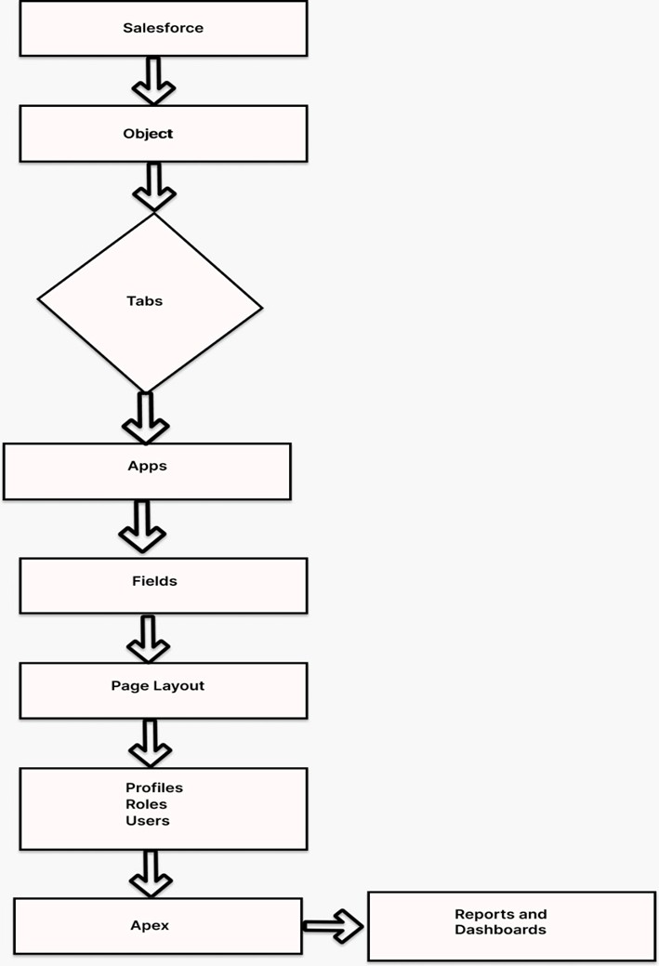

## Technical Archictecture

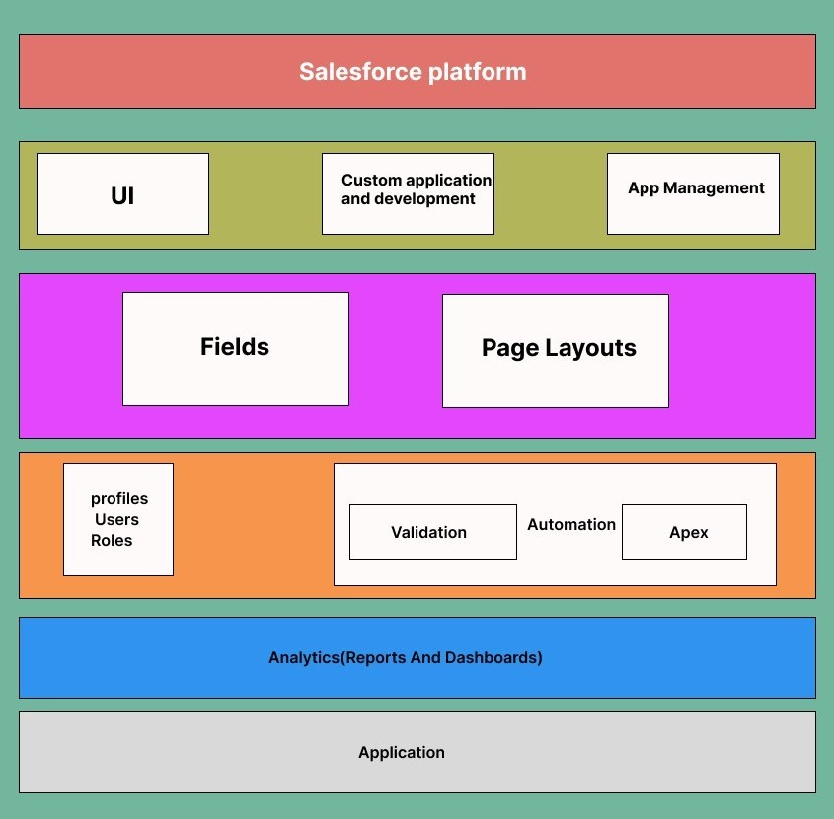

**TABLE-1: Component and Technologies:**

|  |  |  |  |
| --- | --- | --- | --- |
| **S.No** | **Component** | **Description** | **Technology** |
| 1. | User Interface | **Lightning Components**: Use Salesforce Lightning components to design the user interface for employees, managers, and administrators.  **Custom Pages:** Create custom Visualforce  pages for more tailored and complex UI elements | Salesforce |
| 2**.** | Data Model | **Custom Objects:** Define custom objects in Salesforce to represent entities like travel requests, expenses, and approvals. **Master-Detail and Lookup Relationships:** Establish relationships between objects to maintain data integrity.  Custom Fields: Create custom fields to capture specific information, such as travel dates, expenses, and approval  status. | Salesforce |

|  |  |  |  |
| --- | --- | --- | --- |
| 3. | Workflow Automation | **Approval Processes:** Implement Salesforce Approval Processes to automate and streamline the travel request approval workflow.  **Process Builder and Flows:** Use Process Builder and Flows to automate routine  tasks and send notifications. | Salesforce |
| 4. | Reporting and Analytics | **Custom Reports:** Create custom reports to track travel request status,  expenses, and other relevant metrics. | Salesforce |
| 5. | Security | **Role-Based Access Control (RBAC):** Configure RBAC to control who can access and modify data.  **Data Encryption:** Encrypt sensitive data both in transit and at rest.  **Audit Trails:** Maintain audit trails to log user activities for security and compliance  purposes. | Salesforce |
| 6. | Salesforce Development | **Apex:** Use Salesforce's proprietary programming language, Apex, for server-side logic and data manipulation.  **Visualforce:** Develop custom user interfaces with Visualforce pages and components.  **Lightning Web Components:** Create modern, component-based UIs using Lightning Web Components for a more responsive and dynamic  user experience | Salesforce |

**Table-2: Application Characteristics:**

|  |  |  |  |
| --- | --- | --- | --- |
| **S. No** | **Characteristics** | **Description** | **Technology** |
| 1. | Responsive Design | Implement responsive design to adapt to various screen sizes, ensuring a consistent and visually pleasing user  experience. | salesforce |
| 2**.** | Accessibility | Ensure that the application is accessible via multiple devices and browsers, catering to users on desktops, tablets, and mobile devices. This accessibility is crucial for users who need to make or approve travel  requests while on the go. | salesforce |
| 3. | User- friendly | The application should have an intuitive and user-friendly interface to make it easy for employees, managers, and administrators to navigate and use  the system without extensive training. | Salesforce |
| 4. | Scalability | The application should be able to scale with the growing number of users and data, accommodating increasing demands without  significant performance degradation. | salesforce |
| 5. | Performance | Ensure the application's performance meets or exceeds user expectations, with rapid response times for actions such as submitting requests or generating reports. | salesforce |
| 6. | Reporting and Analytics | Enable users to generate custom reports and access analytics tools to gain insights into travel patterns, expenses, and approval efficiency. | salesforce |

# CHAPTER-2 PREPARATION DATA MODELING

* 1. **Salesforce Developer Org**

In Salesforce, a Developer Sign Up or Developer Edition is a special type of Salesforce environment that is primarily used for development, testing, and learning purposes.

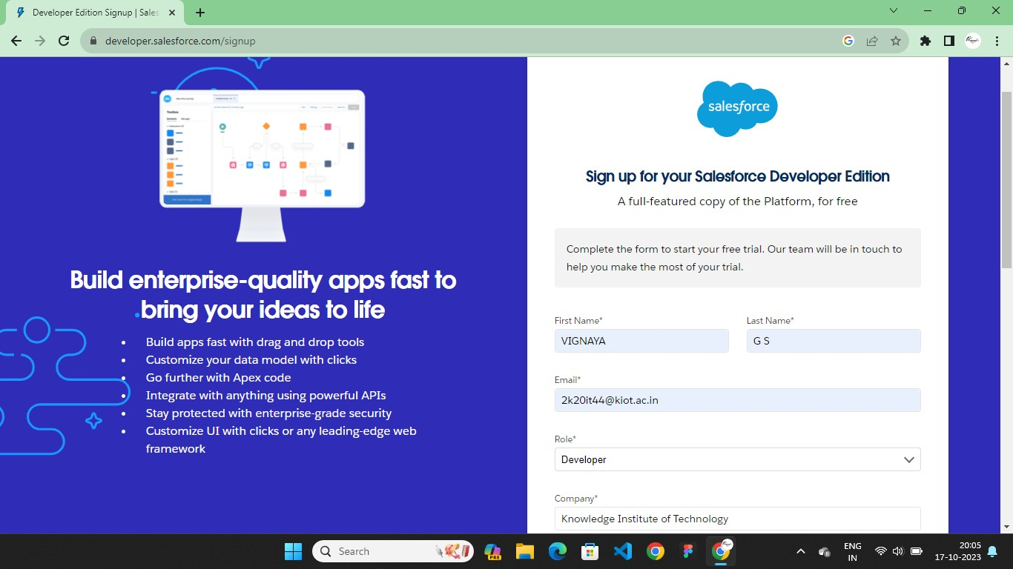

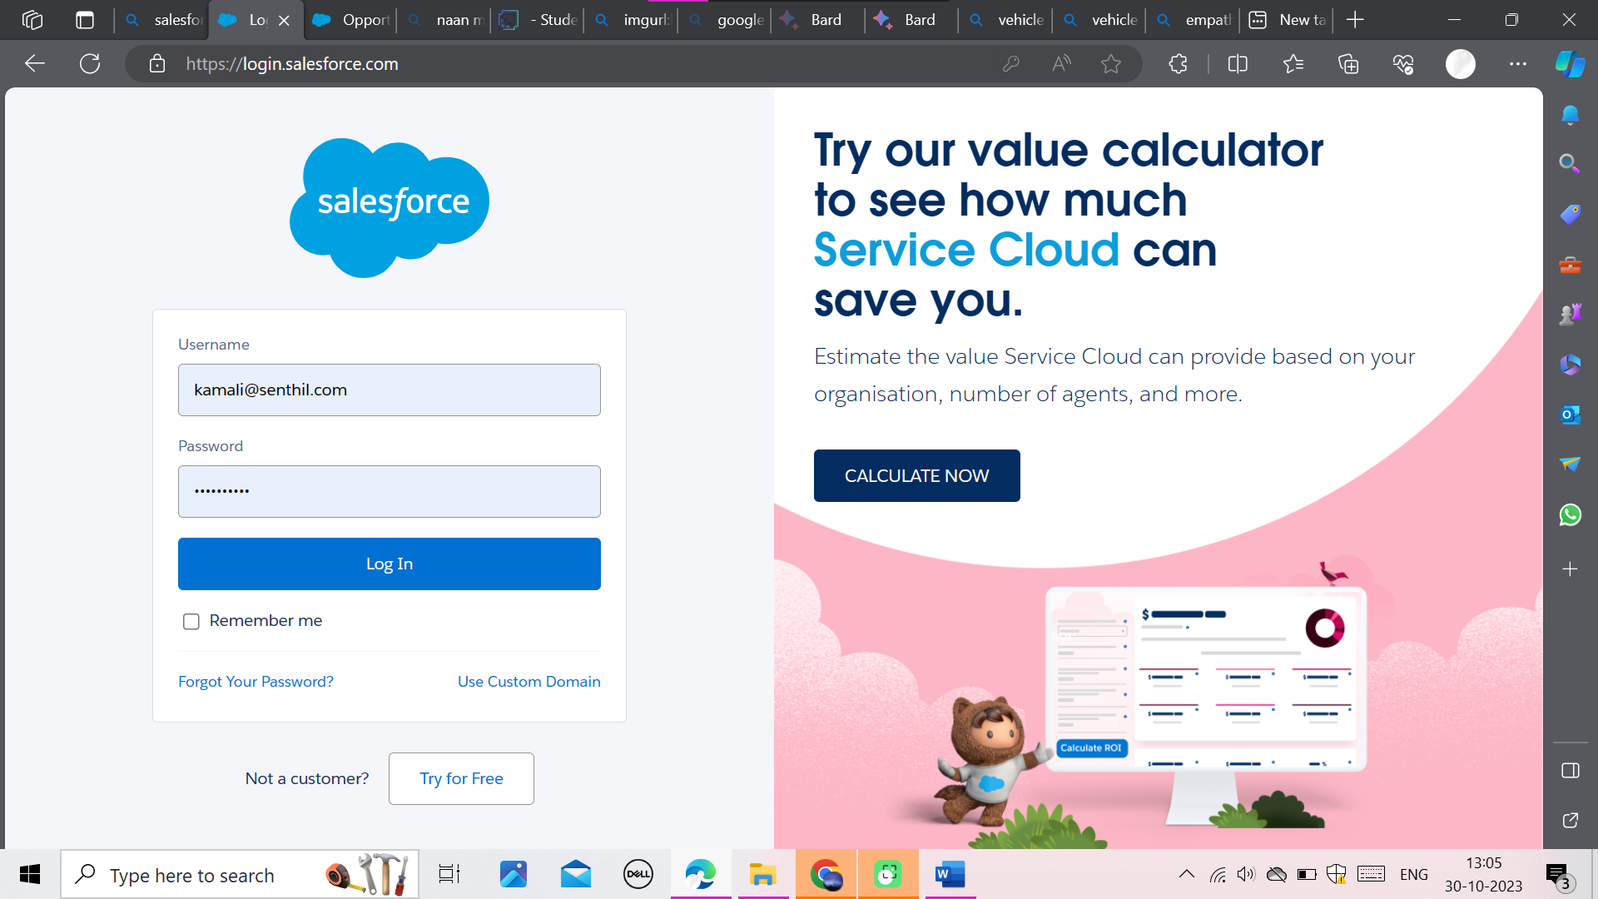

# Account Activation

Activation tracks information about devices from which users have verified their identity.

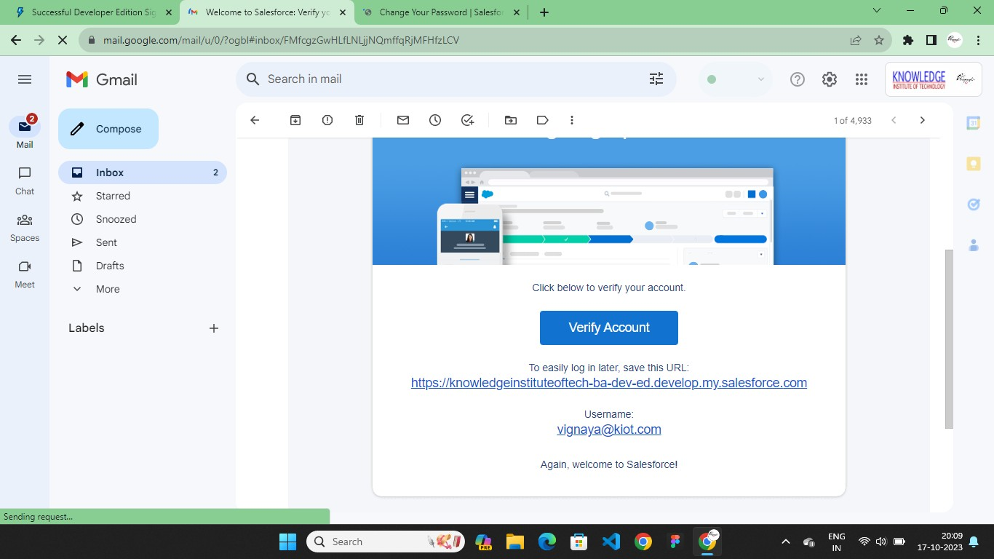

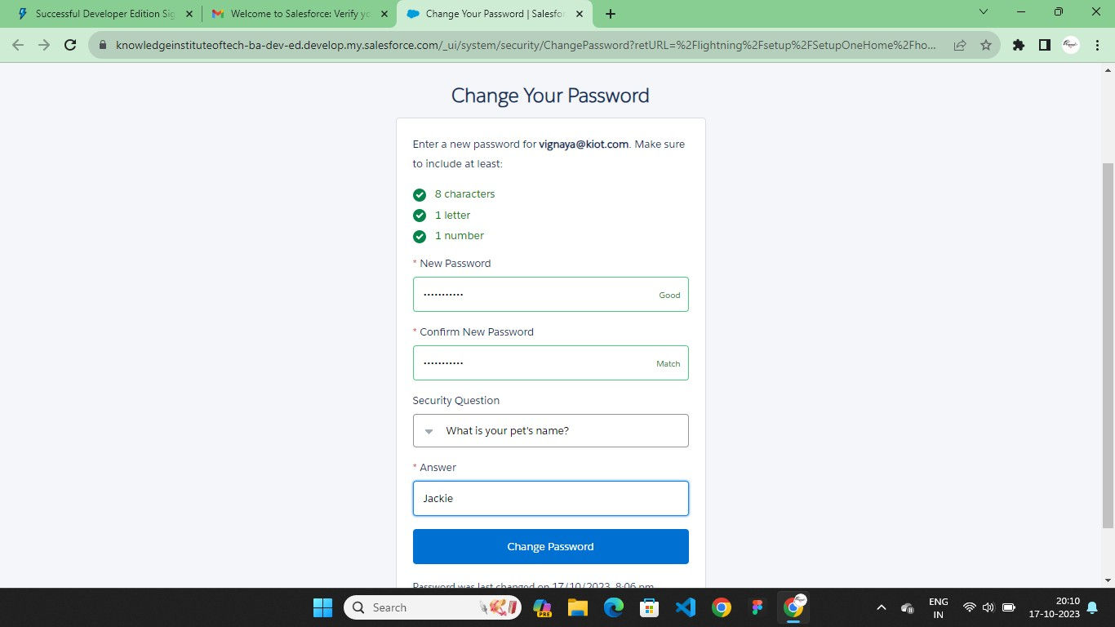

# Custom Object Creation & Tabs

**Custom Object Creation**

Objects are containers for your information, but they also give you special functionality.

Custom objects are create to store information that’s specific to your company or industry. Custom Objects in Travel Approval App:

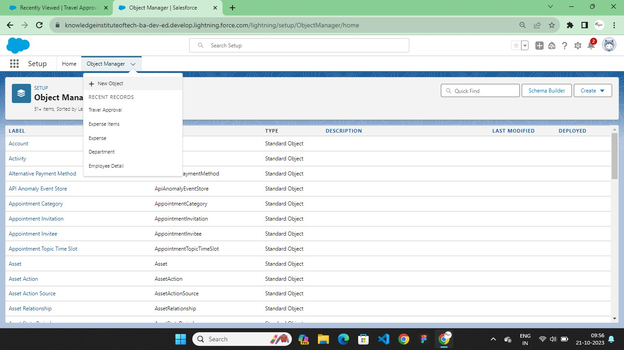

## Fields in Travel Approval Object

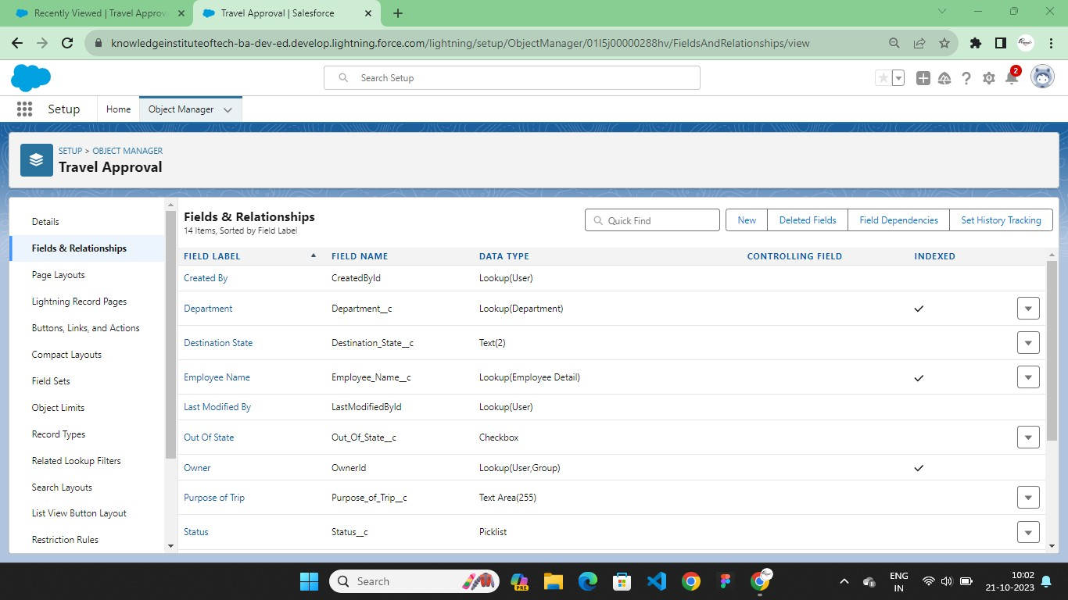

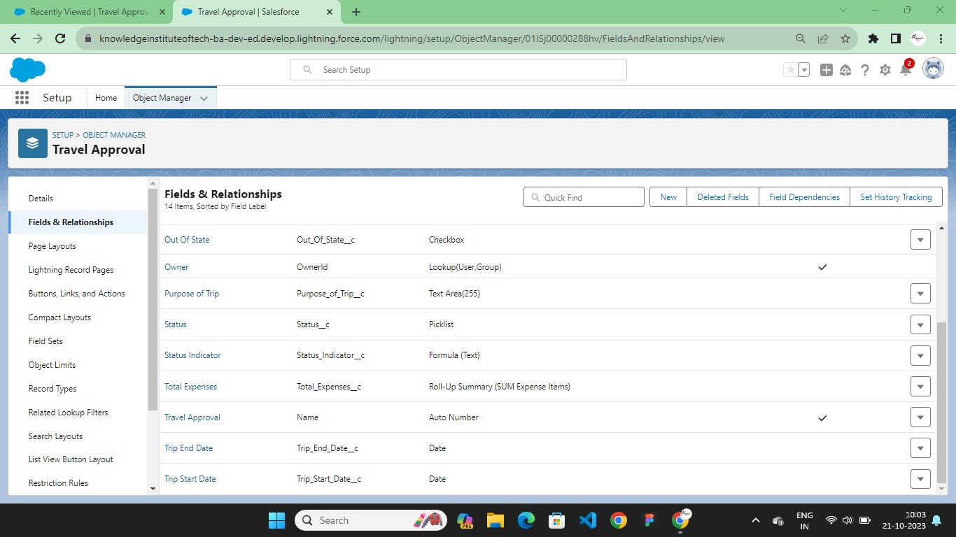

**Fields in Department Object**

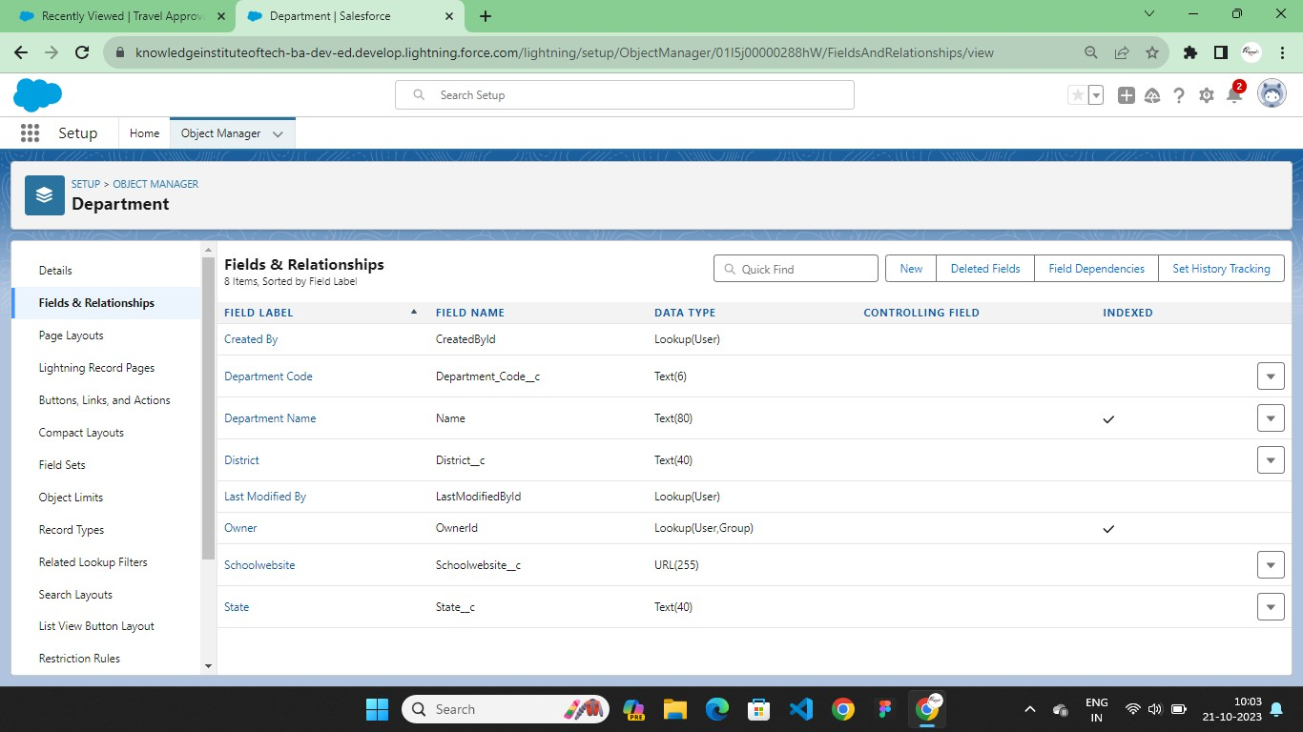

## Fields in Employee Detail Object

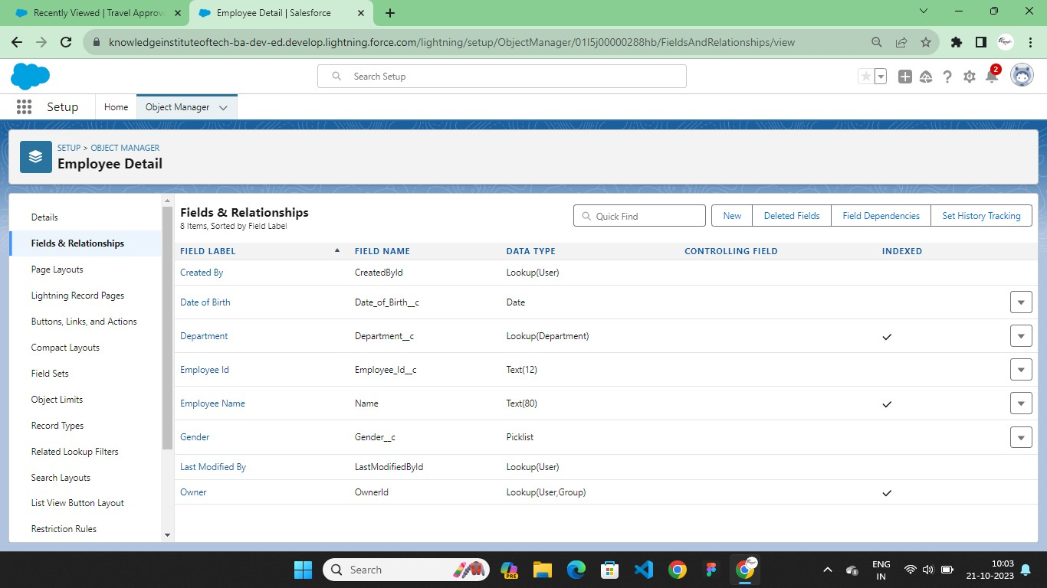

**Fields in Expense Object**

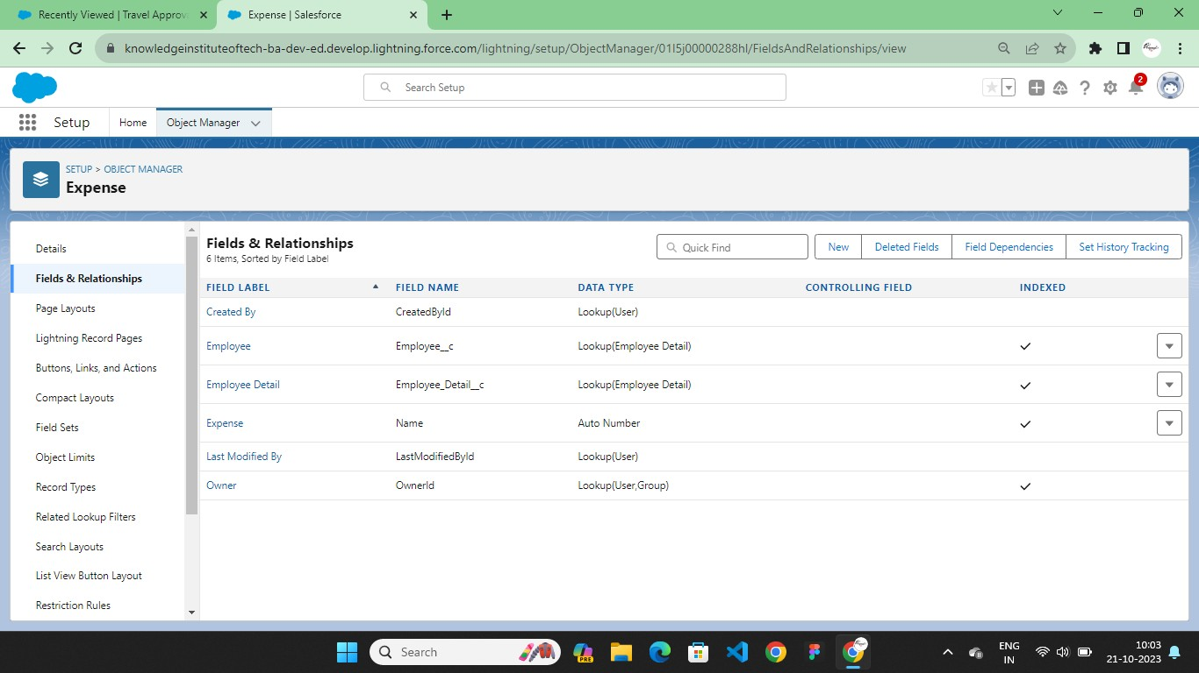

## Fields in Expense Items Object

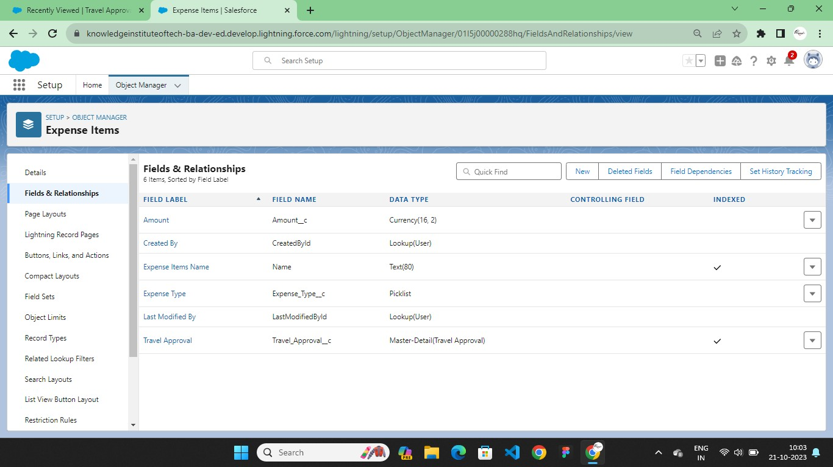

**Tabs**

Salesforce Tabs are like the menu options in a software application. They allow you to access specific functions, objects, or data.

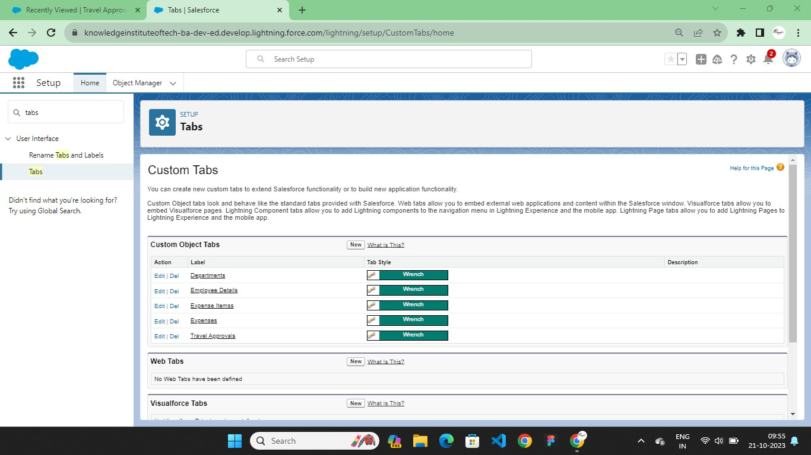

# Lightning App

The Lightning App Builder is a point-and-click tool that makes it easy to create custom pages for the Salesforce mobile app and Lightning Experience, giving your users what they need all in one place.

Create a Travel Approval Lightning App

* + - Build a Lightning app, add tabs, and customize page layouts.
    - Create custom objects and fields for the app.
    - Define relationships between objects.
    - Import data and test the app.

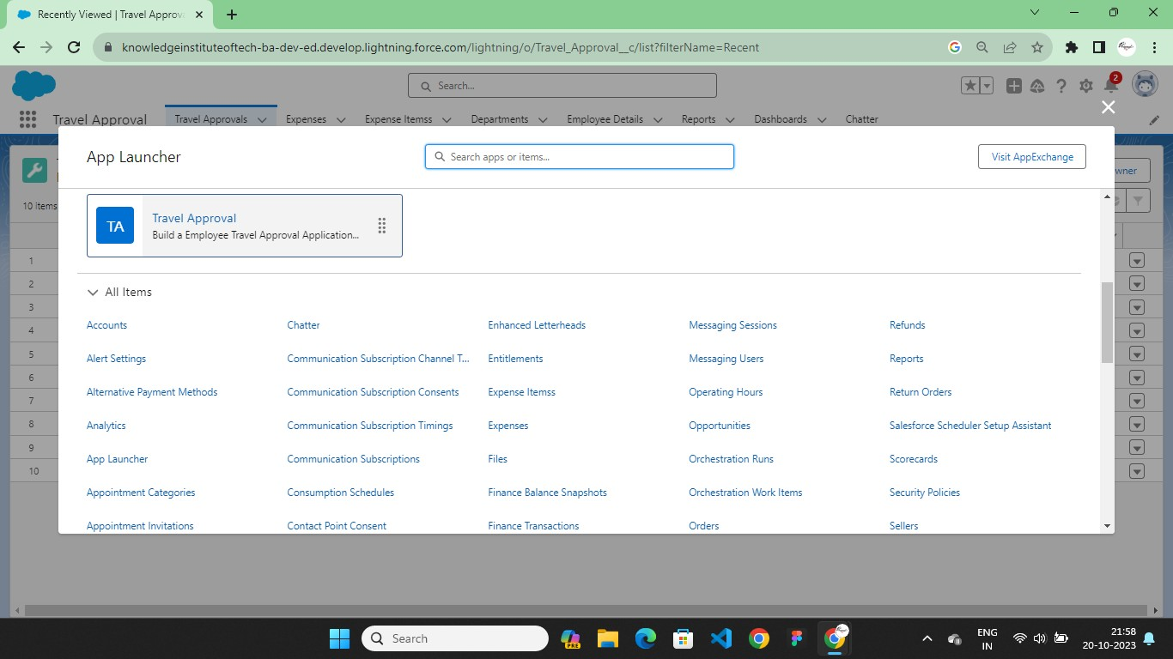

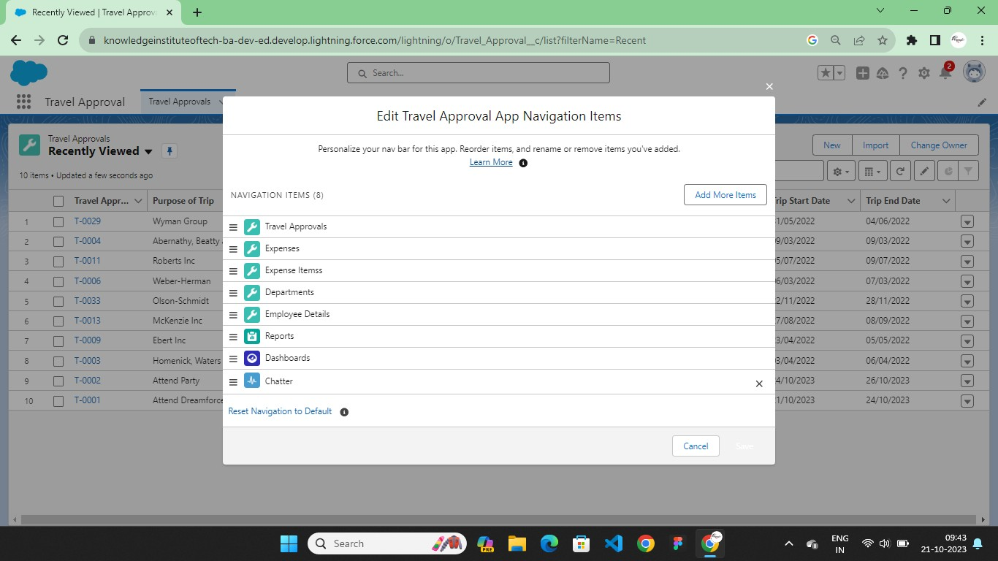

## Data Import

The Data Import Wizard is one of various tools available to Salesforce users for importing data. The tool is best used when importing data into the Account, Contact, Lead, or Solution objects along with any custom objects within your Salesforce organization

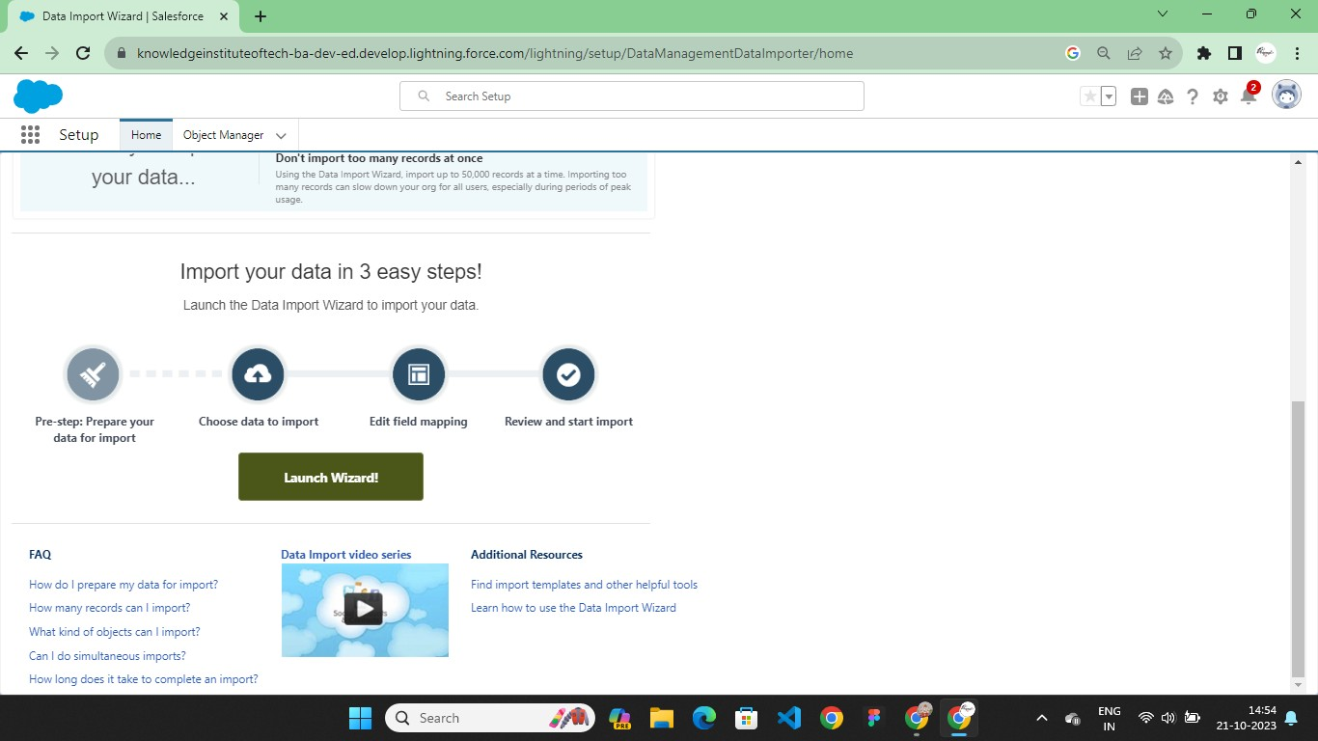

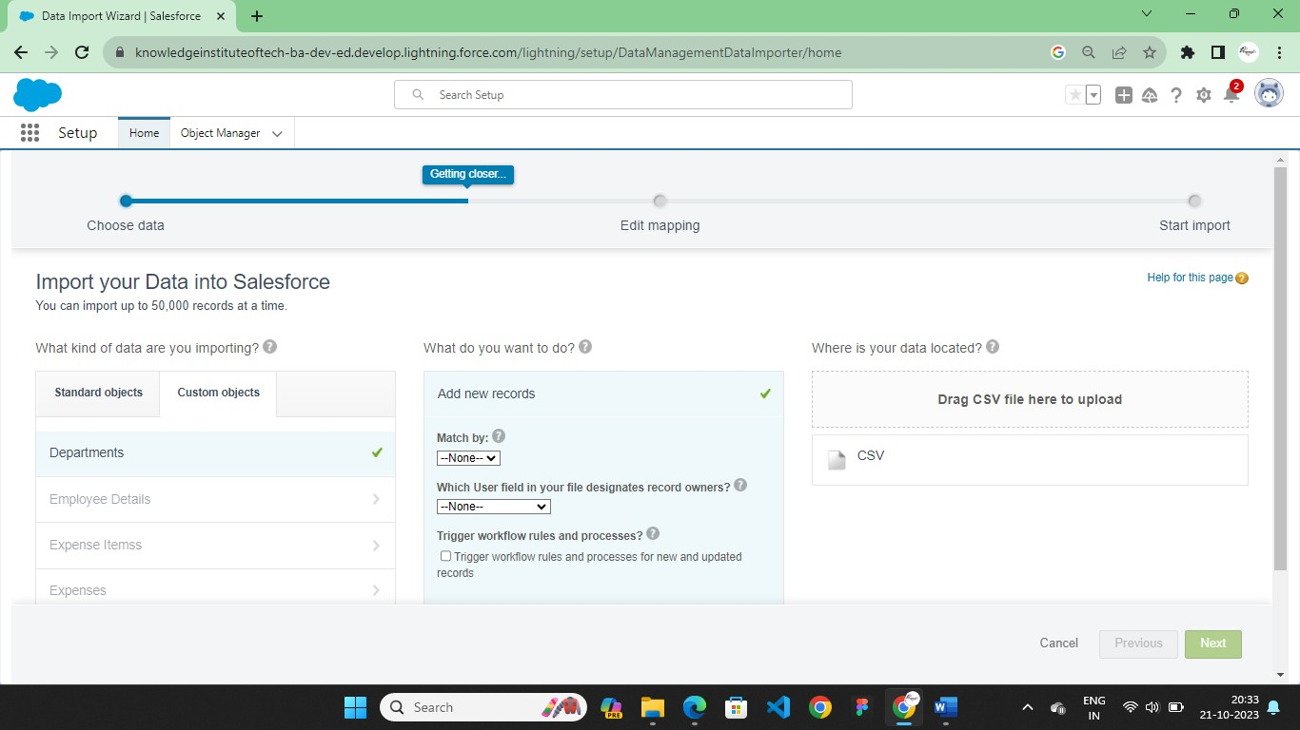

# Relationship between Objects

## Master-Detail Relationship

A master-detail relationship defines the relationship between the parent and the child.

The master table defines the parent relation and the detail defines the child relation.

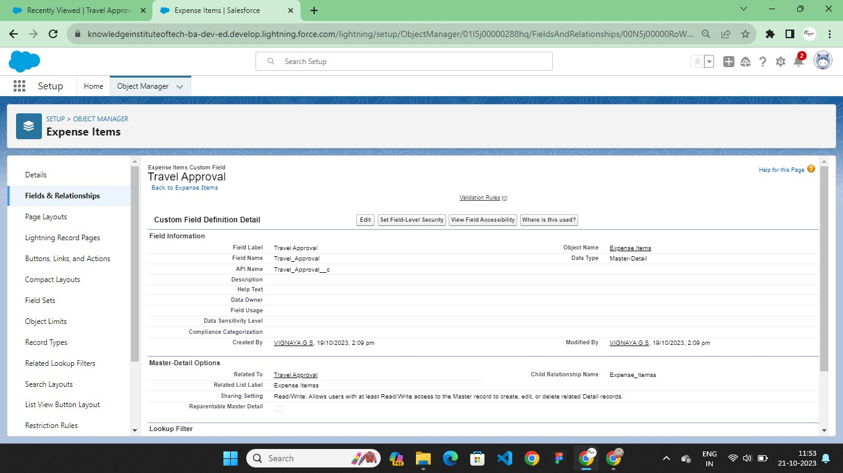

## Look up Relationship

Lookup Relationship in Salesforce relates two objects together but does not affect deletion (cascade delete functionality) or security.

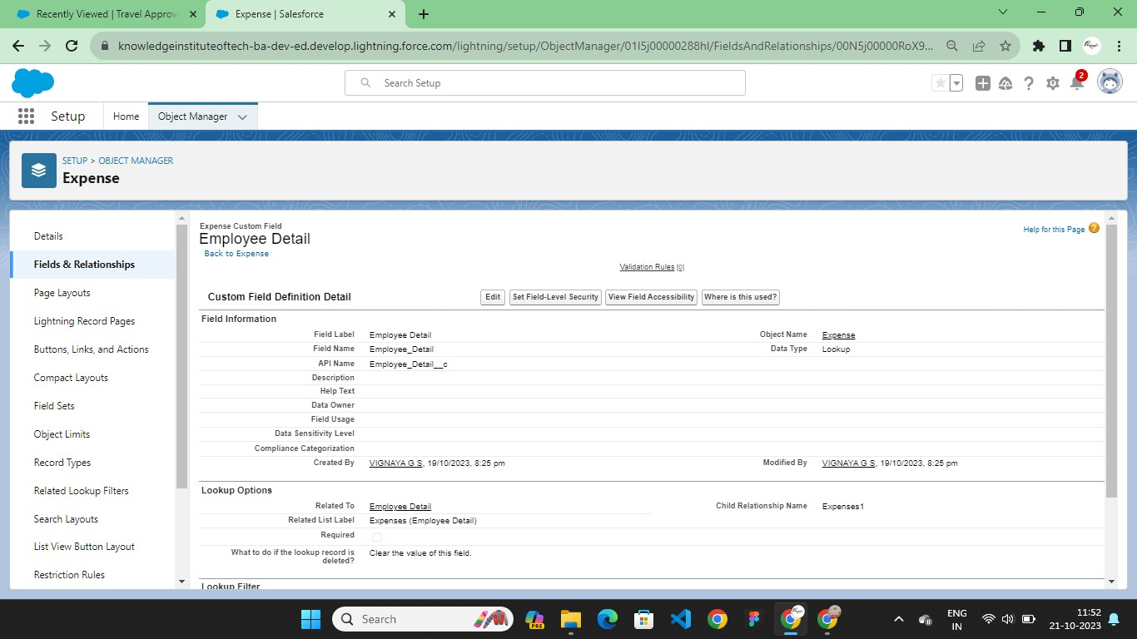

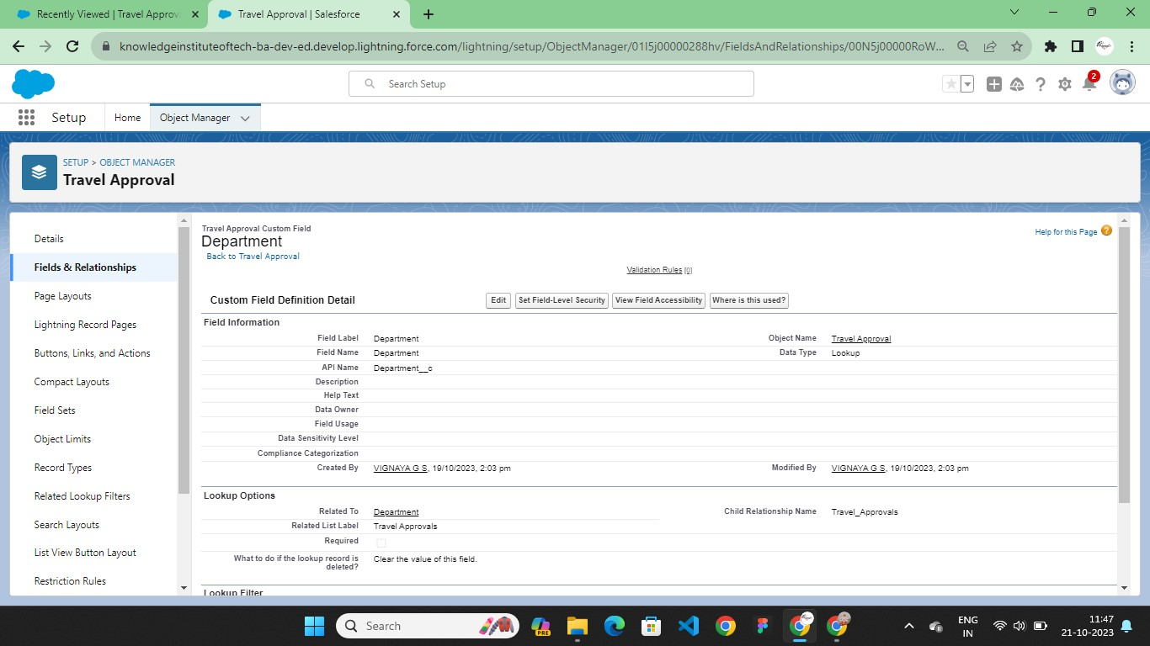

## Roll-up Summary

Roll-Up Summary Fields in Salesforce summarize data of particular fields from a set of related detail records and automatically display the output on the master record.

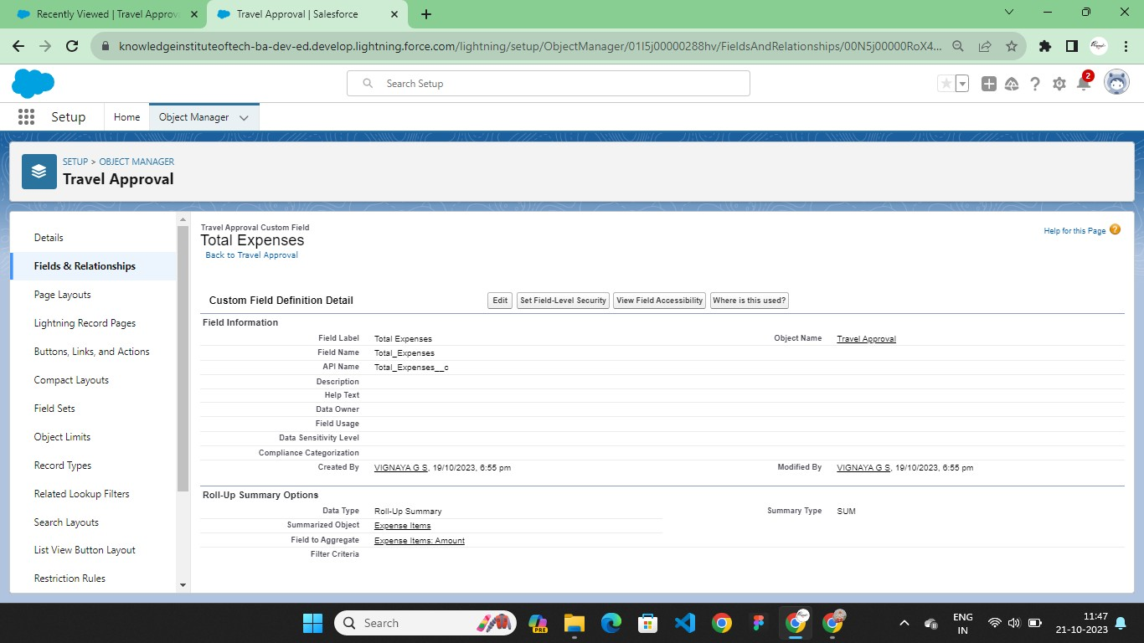

# Customize User Interface

Customize your app's page layouts, compact layouts, and actions.

## Page Layout

A page layout determines the fields, sections, related lists, and buttons that appear when users view or edit a record. You can modify an object’s default page layout or create a custom page layout.

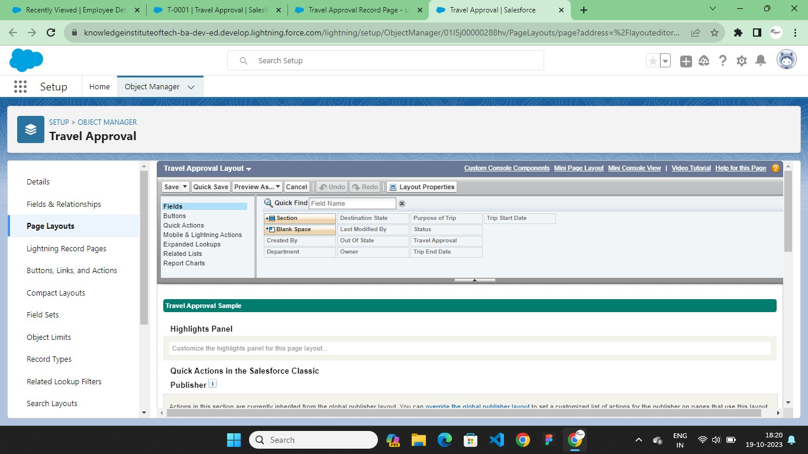

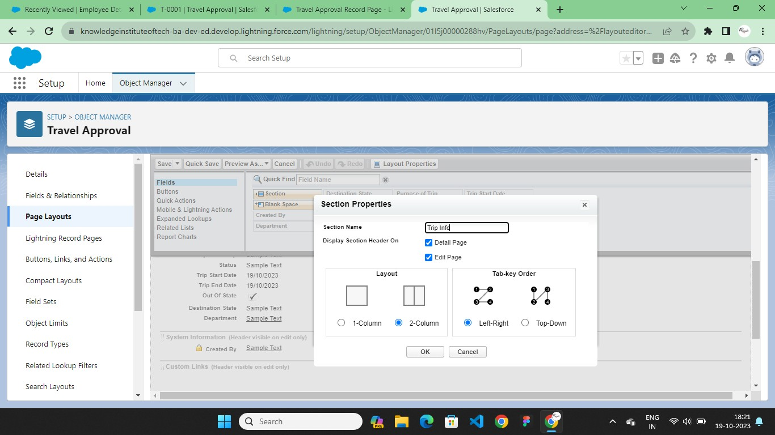

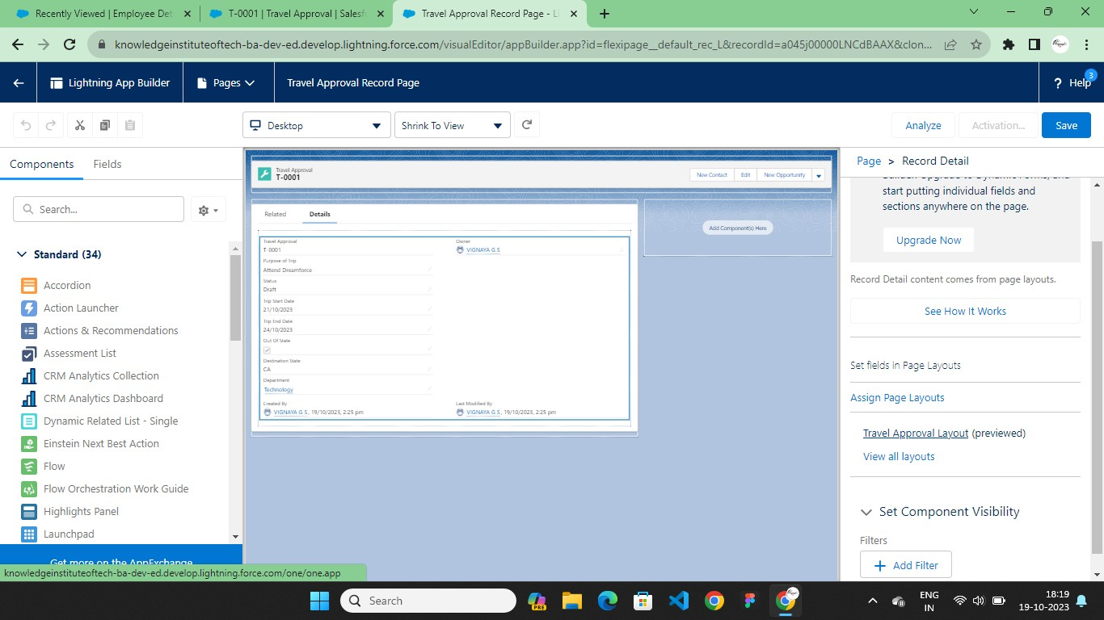

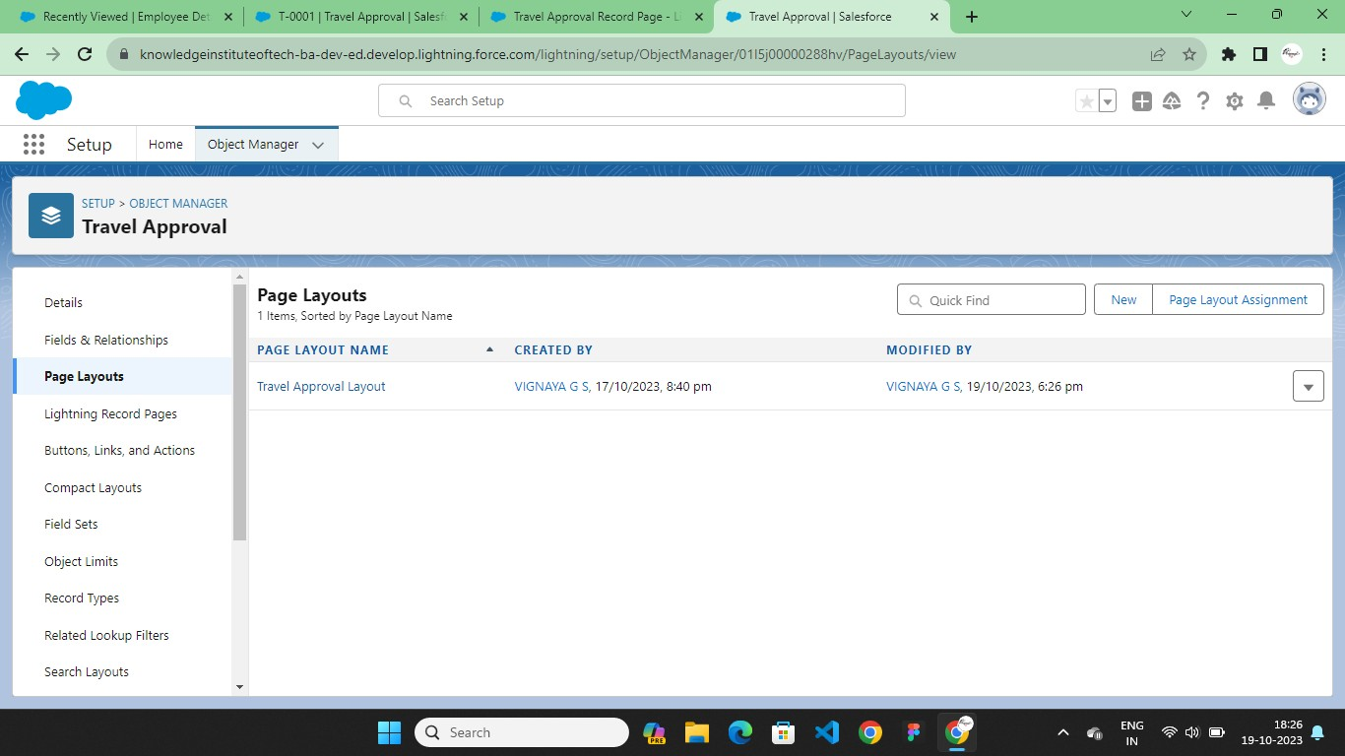

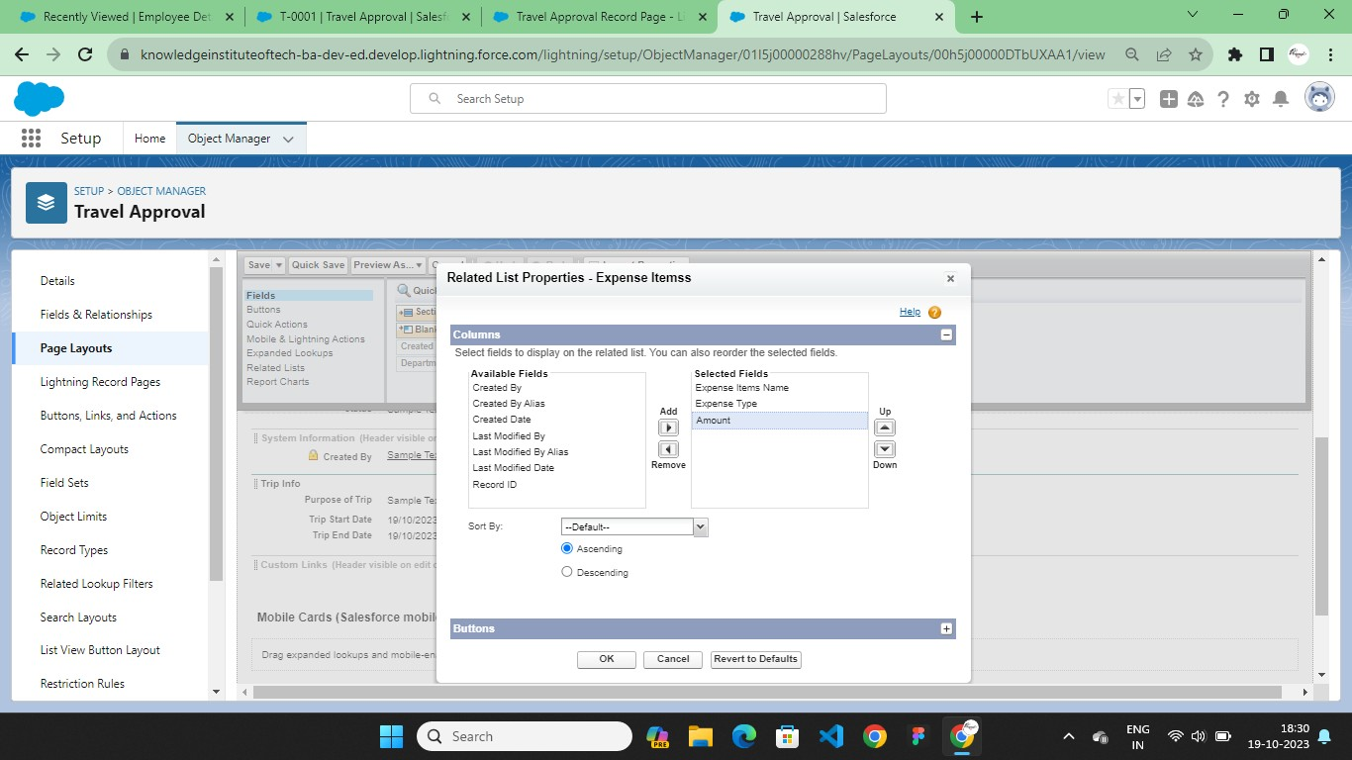

## List View

A list view is a set of search conditions that displays records that match the search conditions.

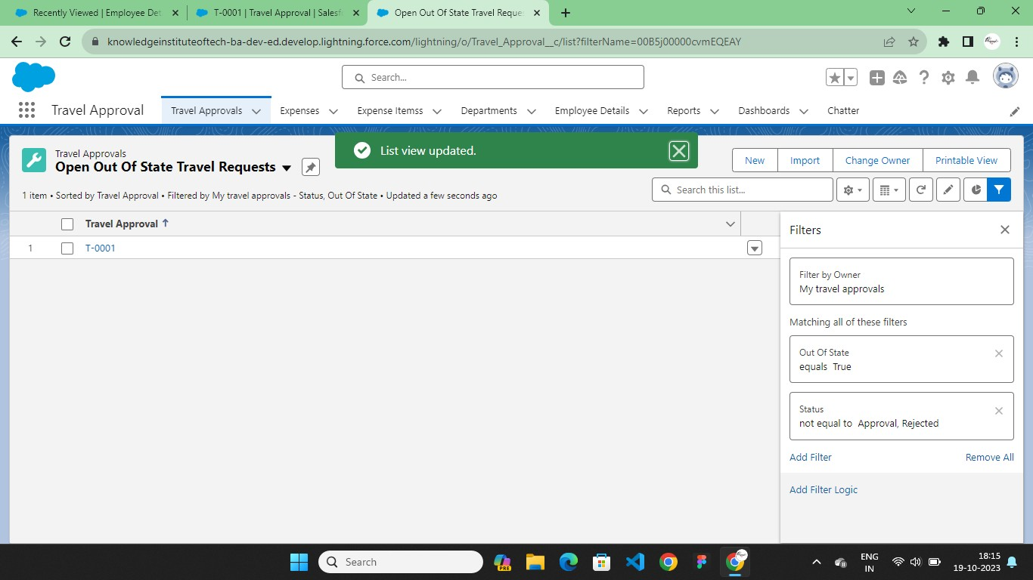

## Search Layout

Create search layouts for standard and custom objects, ensuring the layout shows users what's most relevant to them.

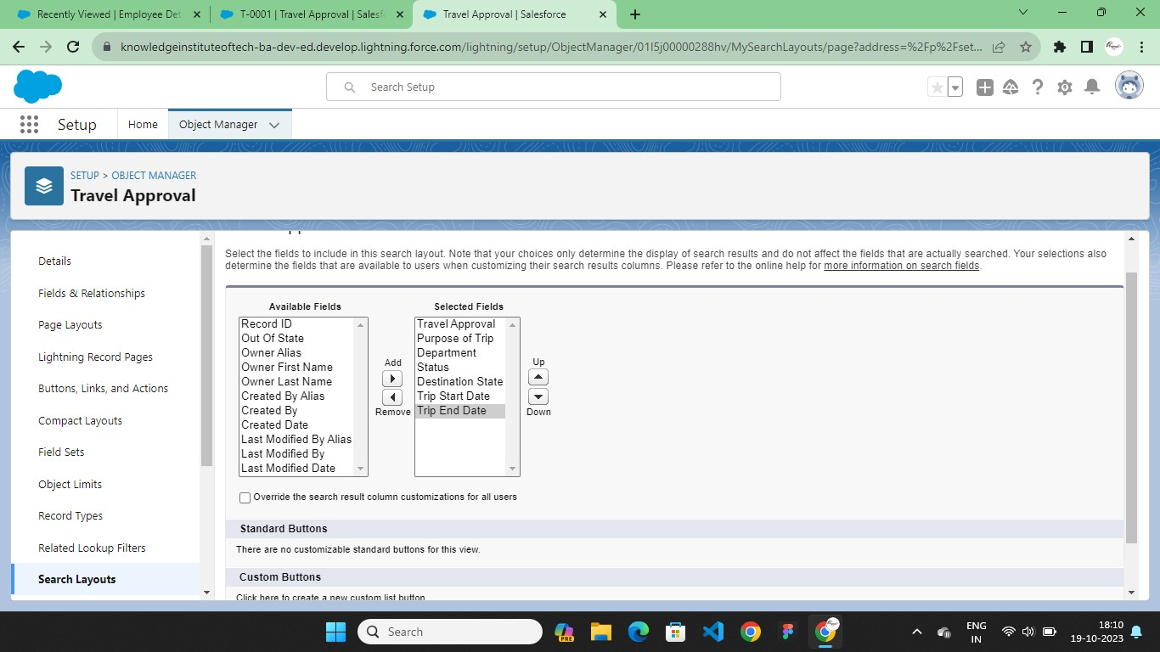

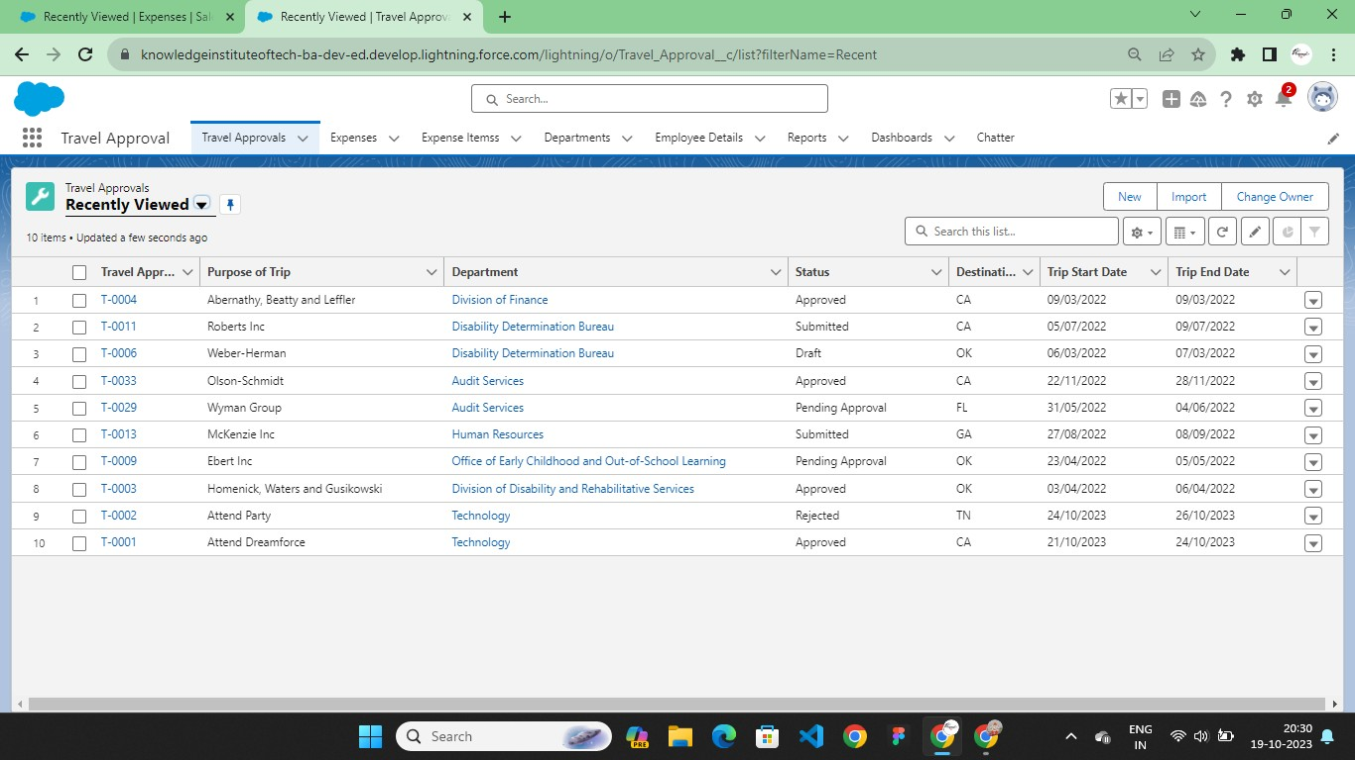

# Business Logic

## Validation Rules

Validation rules let you set up business-specific criteria to prevent users from saving invalid data in one or more fields.

A validation rule evaluates a formula when a record is saved.

If a rule’s criteria aren’t met, users see a custom error message and the record doesn’t

save.

If a rule’s criteria are met, the record saves.

Use validation rules to improve data quality by applying conditions, ensuring proper

formatting, and enforcing consistency.

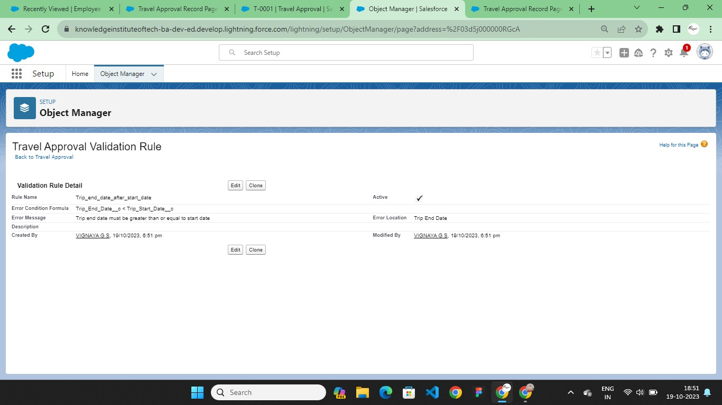

# CHAPTER-3

**USERS & DATA SECURITY**

# 3.1 User Creation & Setup Approvals

Before customizing the travel app, first create a new user, Eric Executive, and set him up as manager. This involves assigning roles and profiles so that Eric has the correct permissions to approve travel requests.

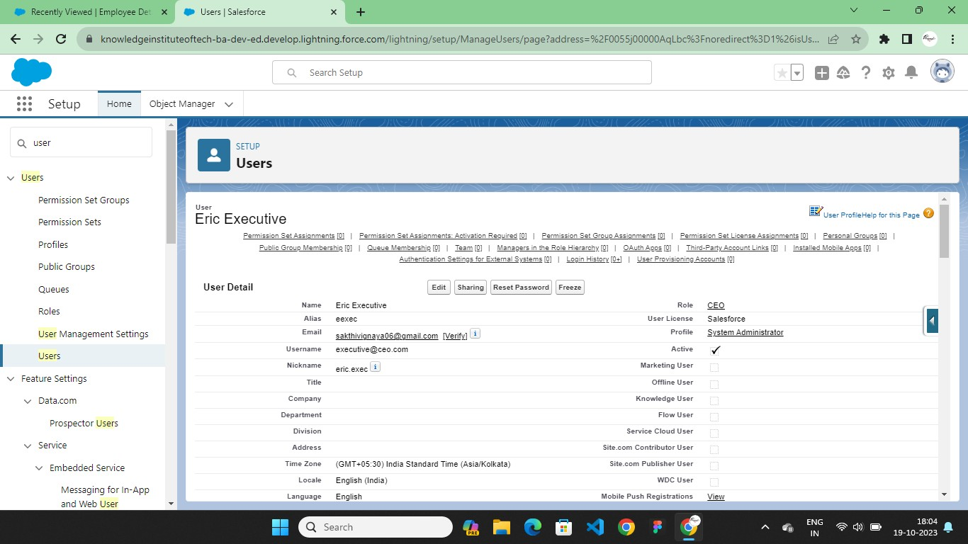

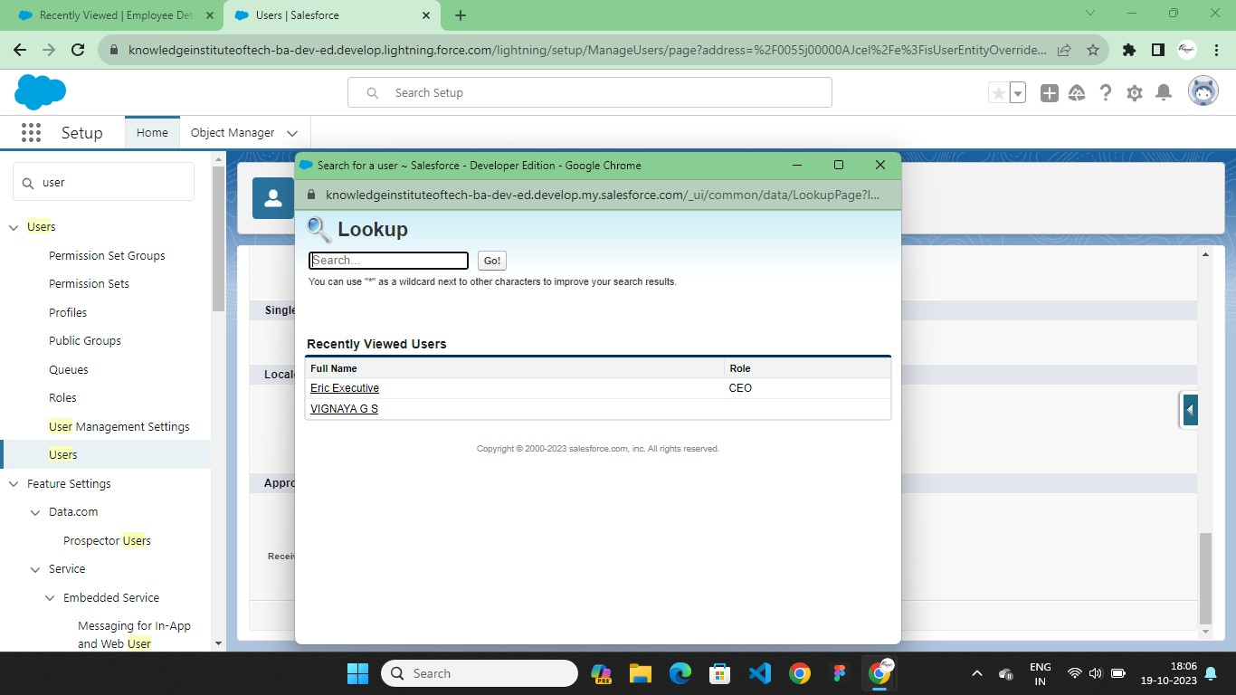

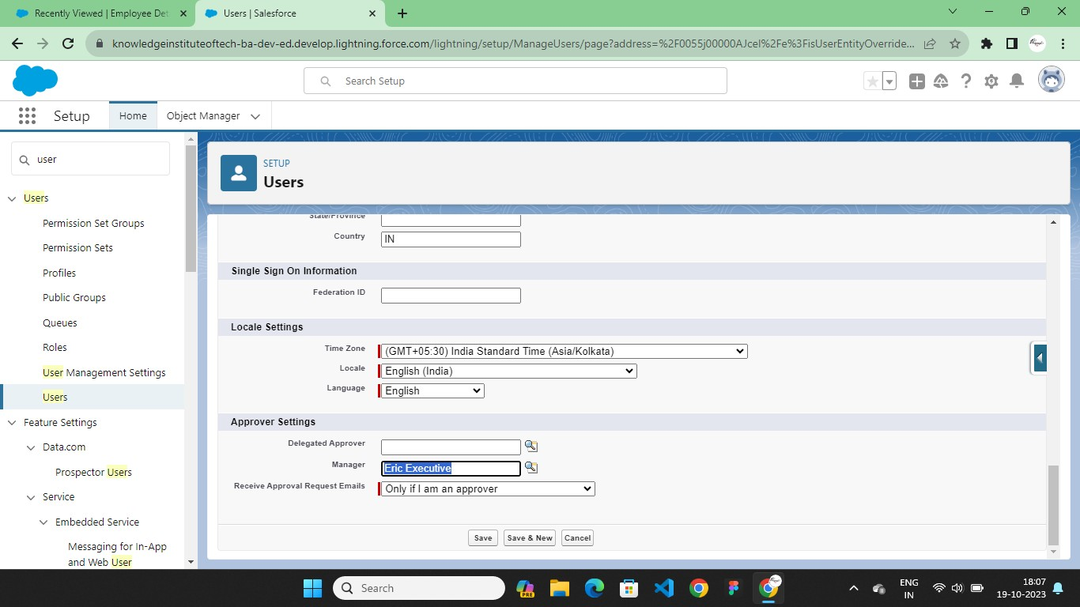

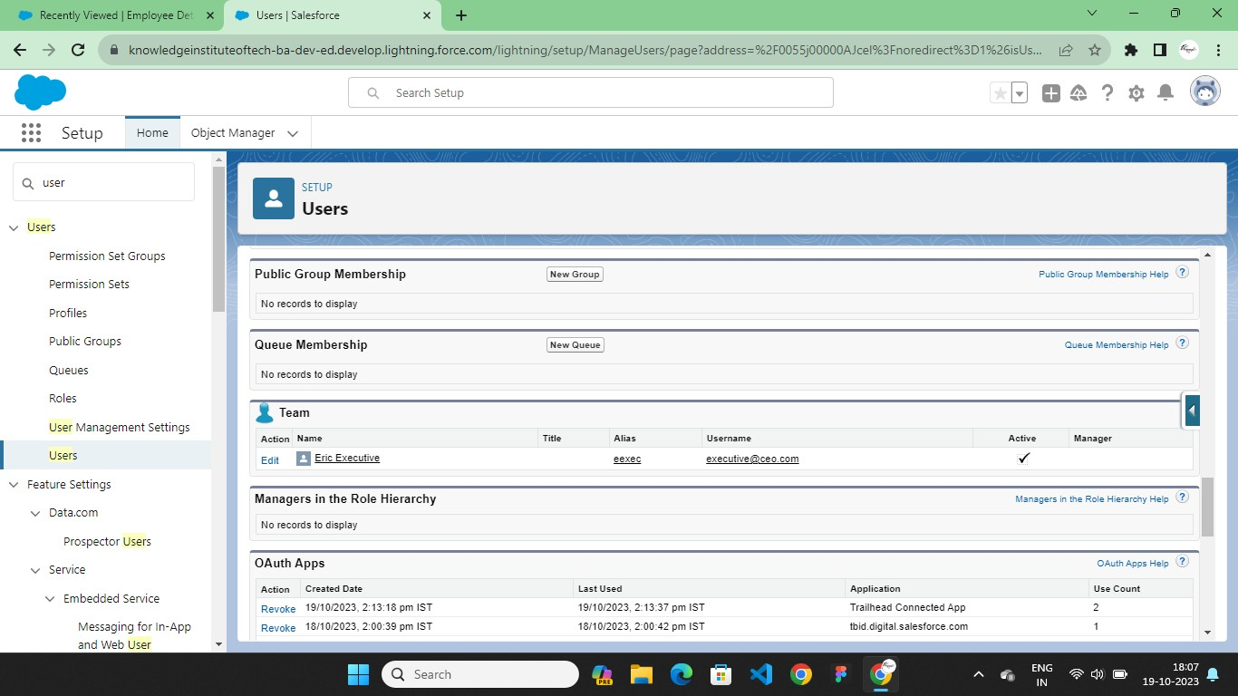

# CHAPTER-4 AUTOMATION

* 1. **Flow**

The last business rule functionality to implement before testing your application is a rule to set the Out-of-State checkbox field on the Travel Approval object if out-of-state travel has been chosen. Salesforce offers workflow capabilities that provide a declarative, drag-and- drop design environment to build our business process logic.

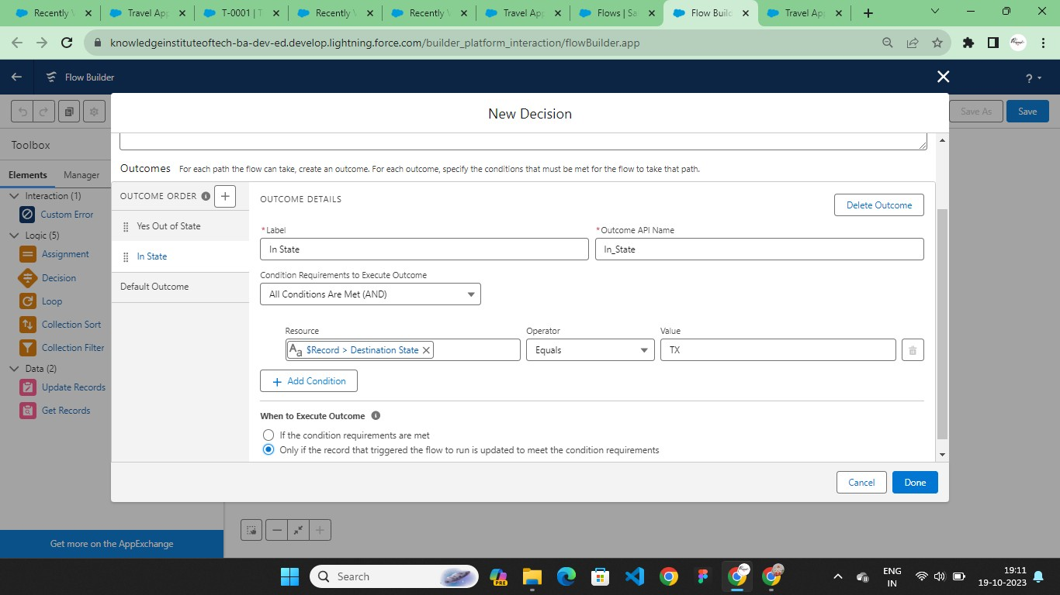

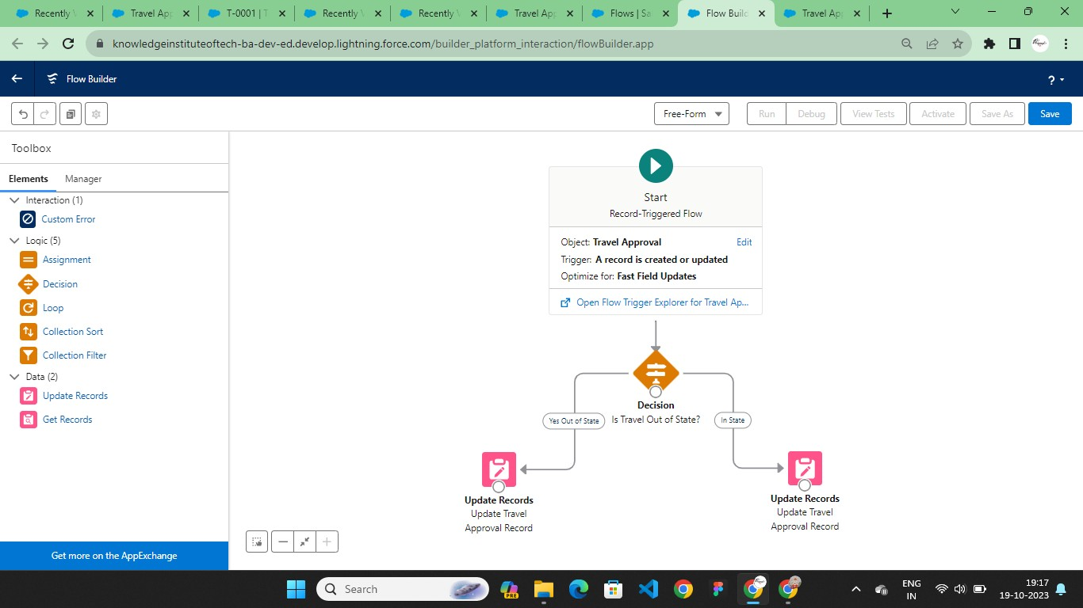

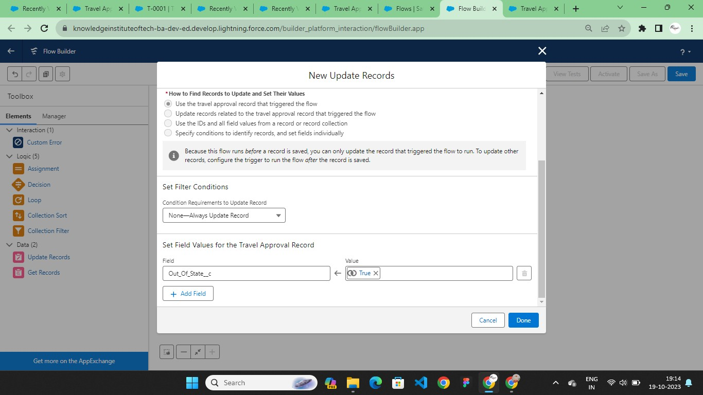

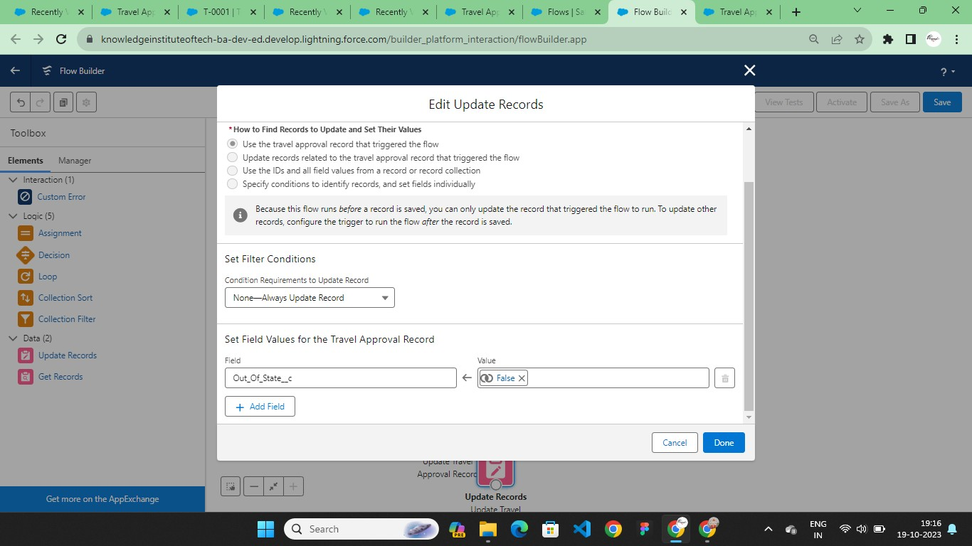

# Approval Process

An approval process is an automated process your agency can use to approve records in Salesforce.

An approval process specifies the criteria a record must meet before it can be submitted for approval, the steps necessary for a record to be approved, and who must approve it at each step.

A step can apply to all records included in the process or just records that have certain attributes. An approval process also specifies the actions to take when a record is approved, rejected, recalled, or first submitted for approval.

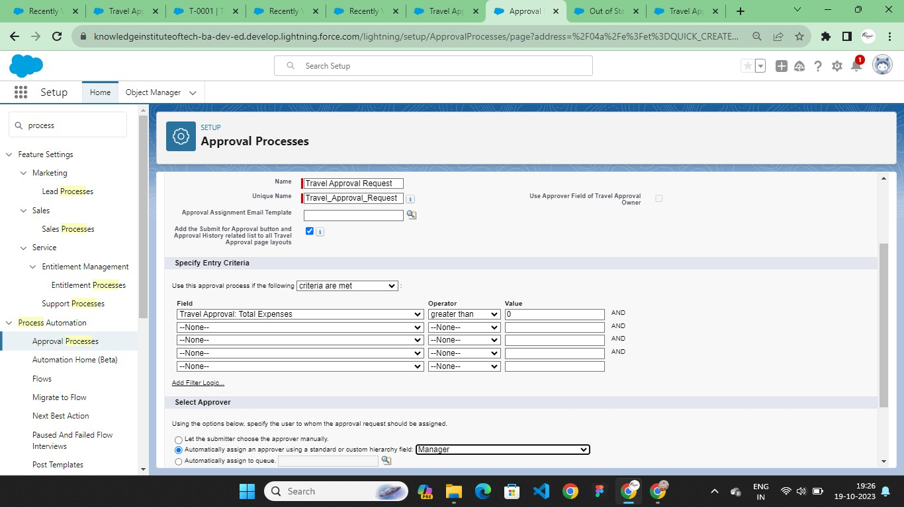

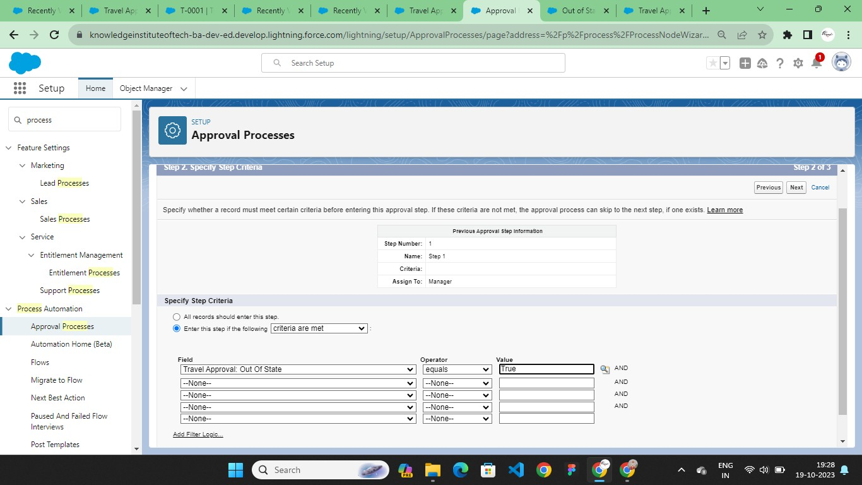

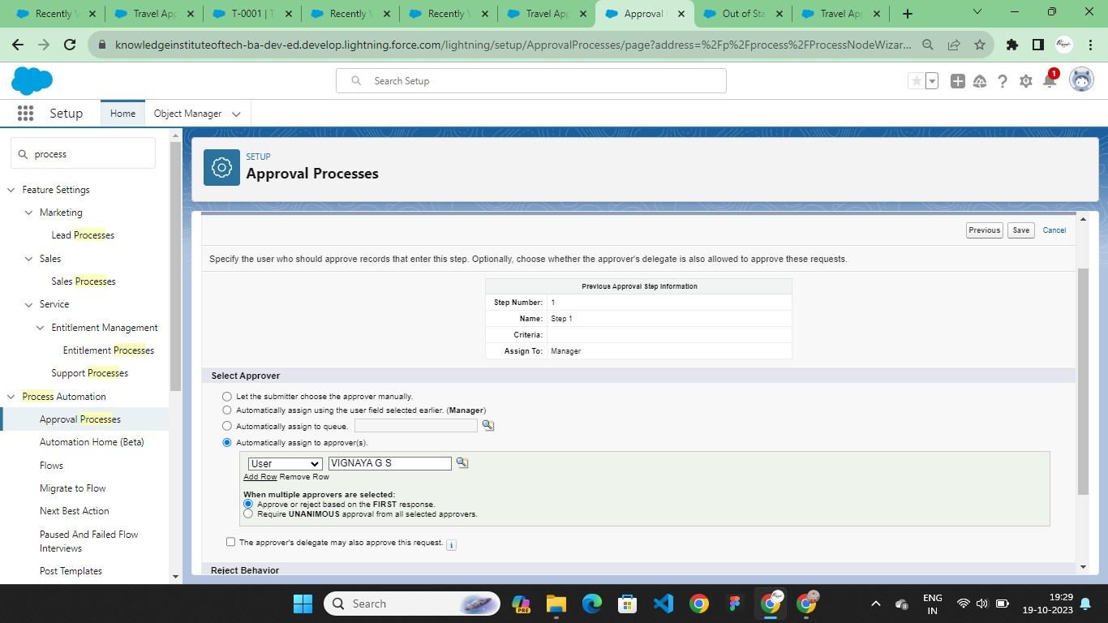

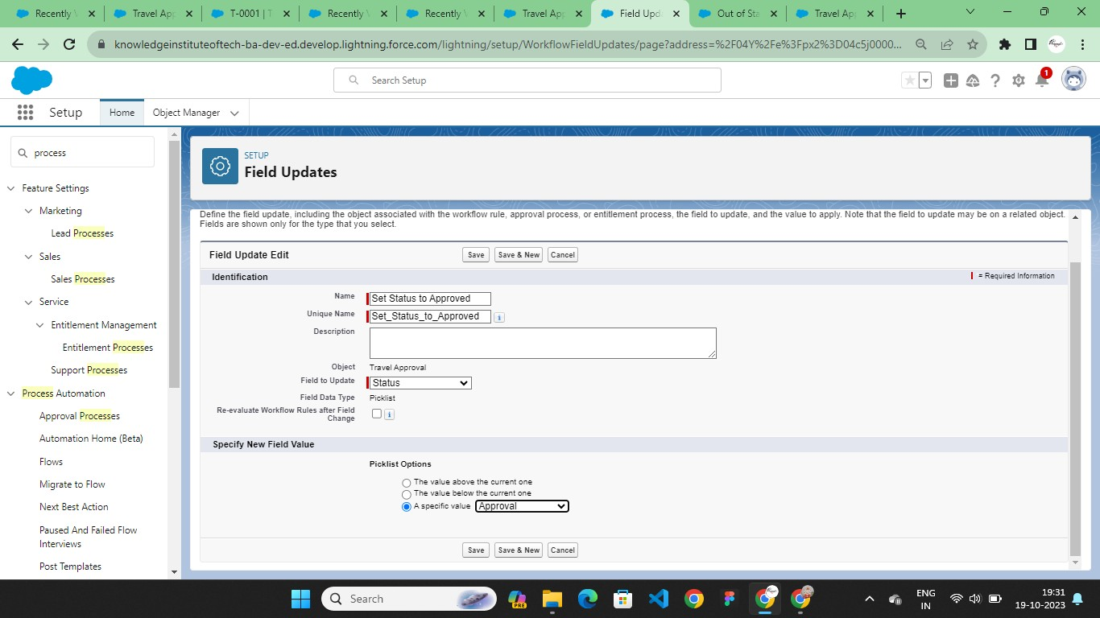

# Final Views

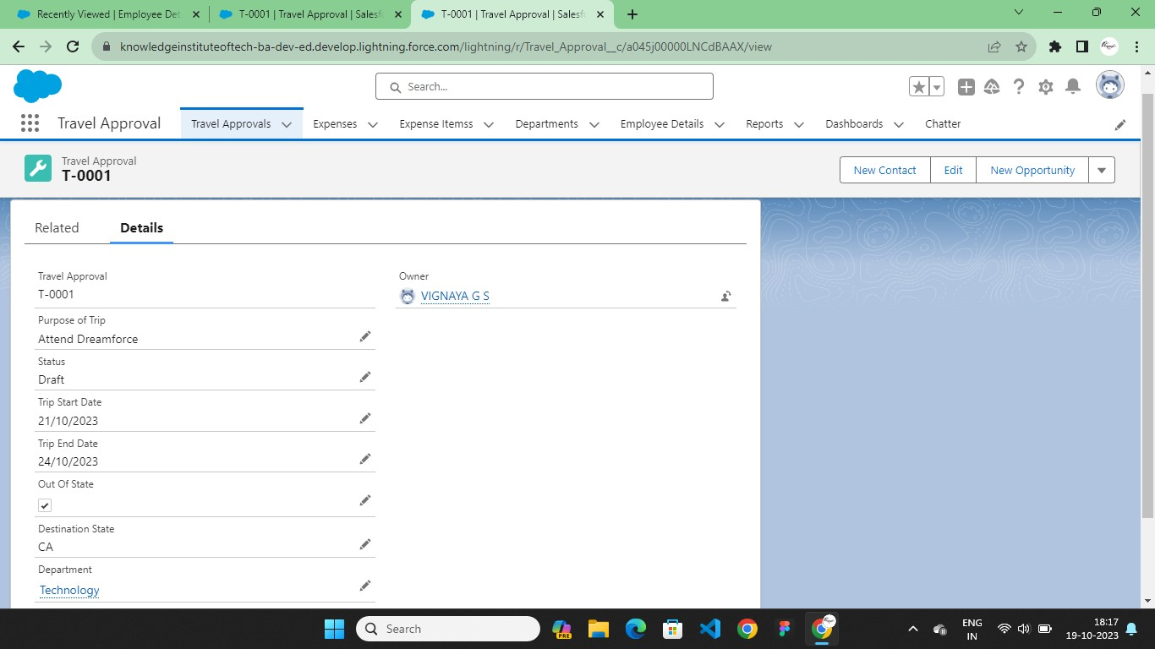

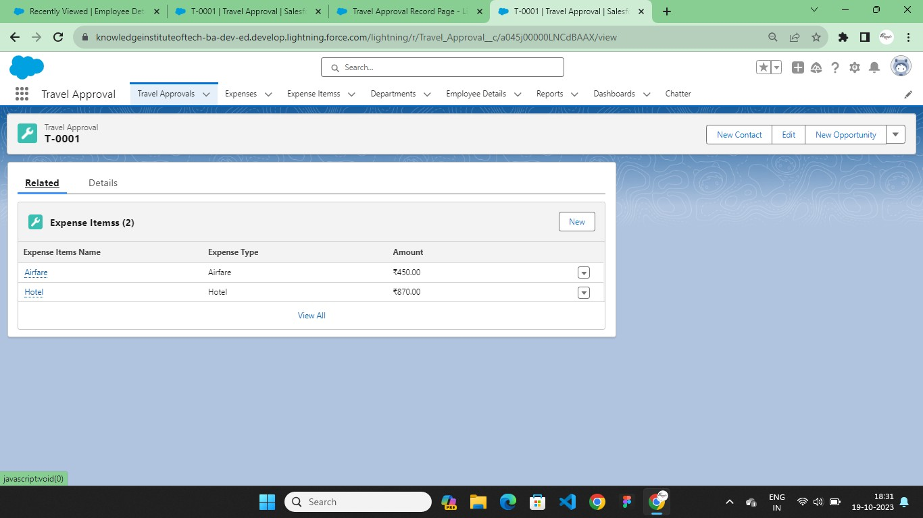

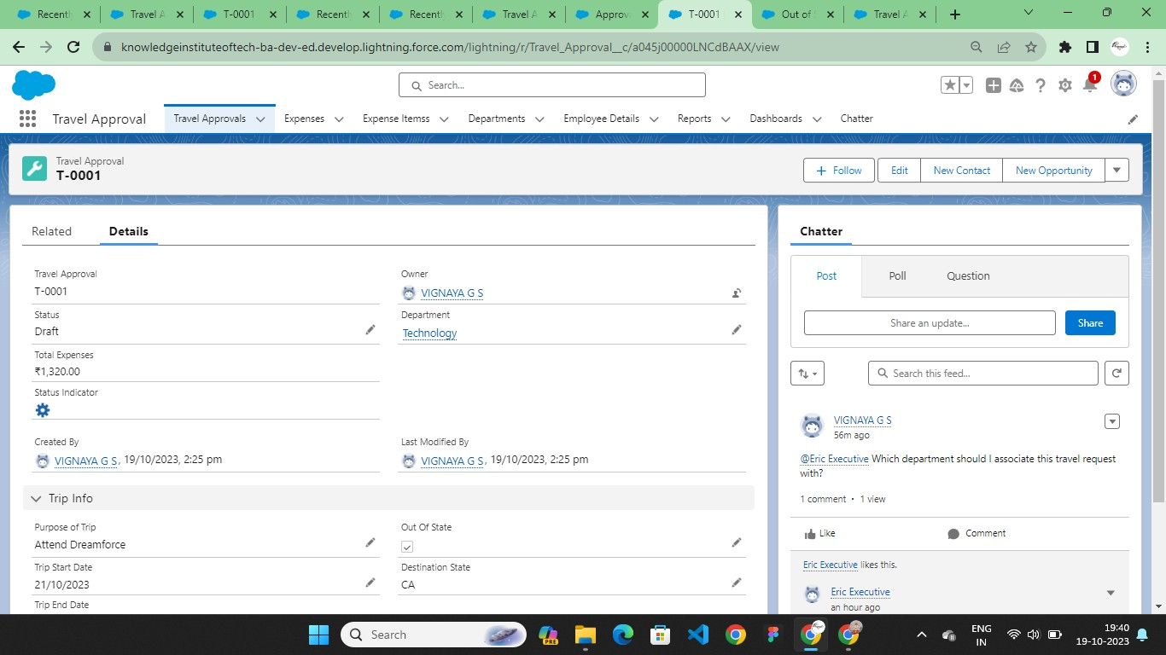

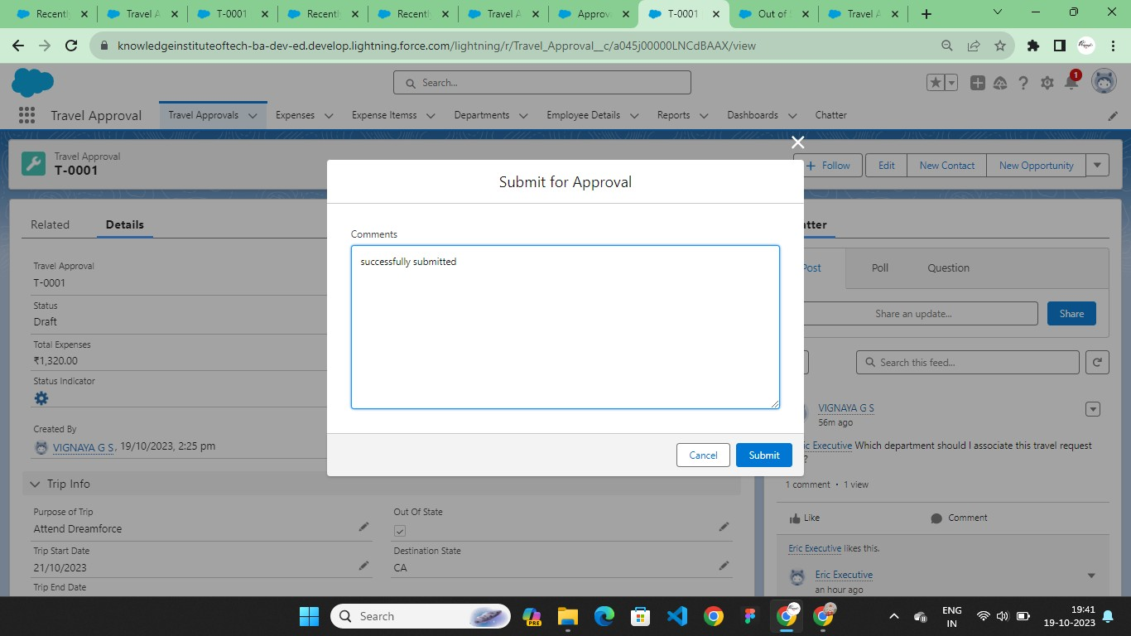

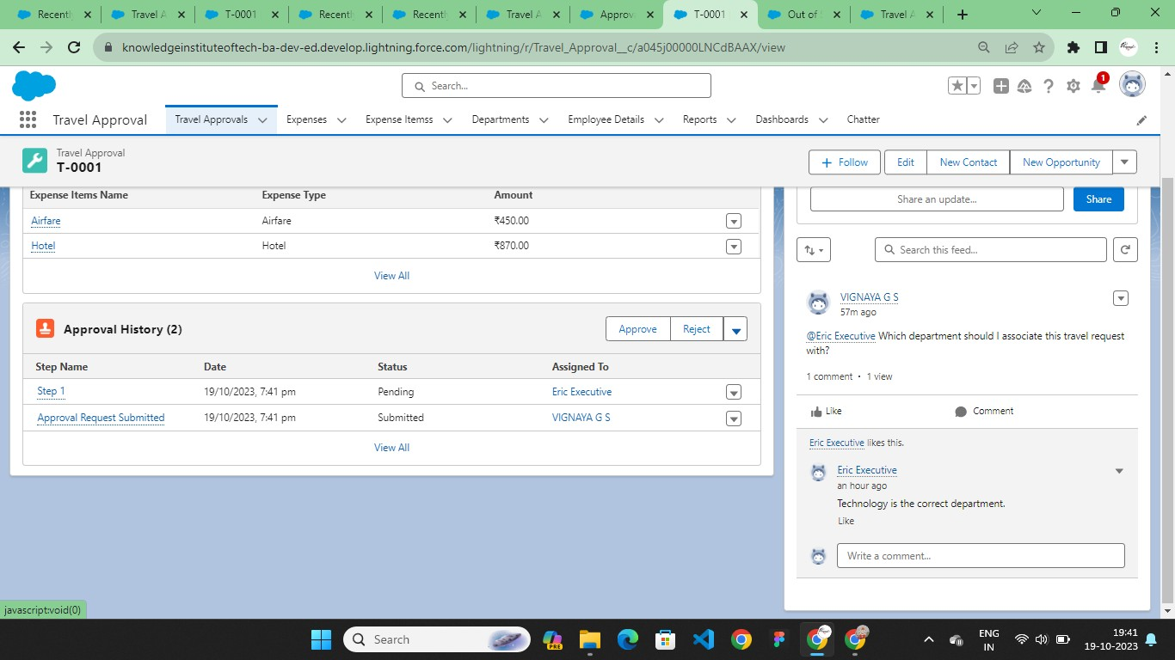

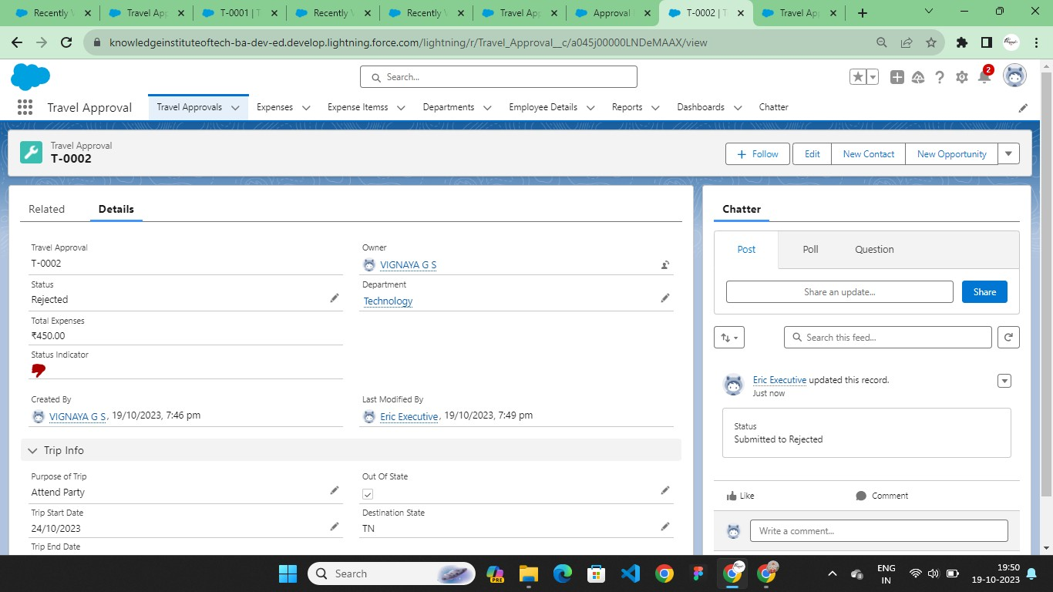



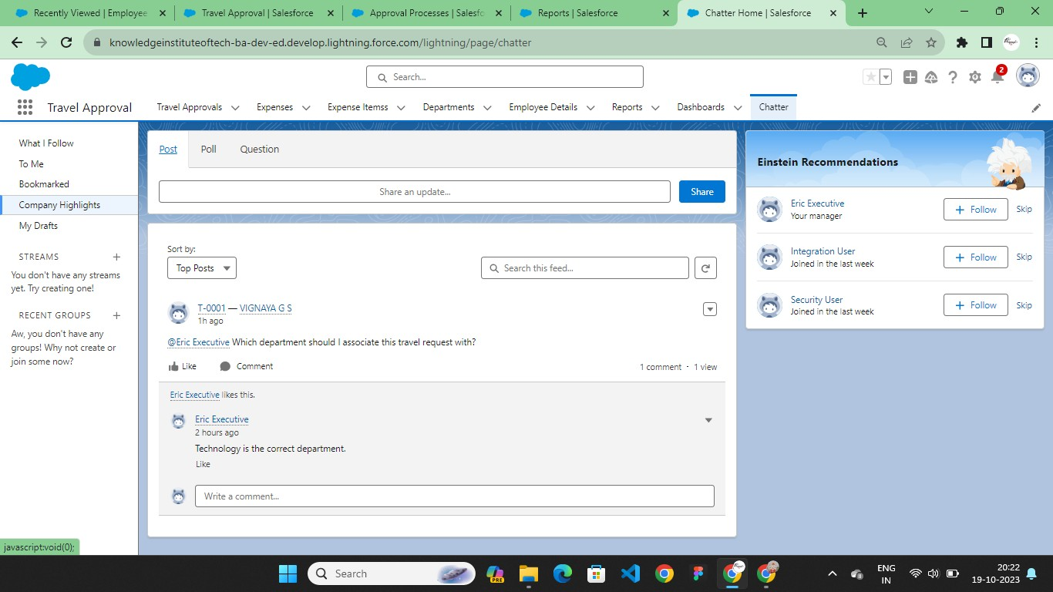

**CHAPTER-5 REPORTS & DASHBOARD**

# Reports

A Salesforce report is a list of data generated based on filter criteria. Salesforce Reports helped us predict trends and gives us the advantage to increase profits.

The report builder provides a drag-and-drop interface to easily build and customize your reports.

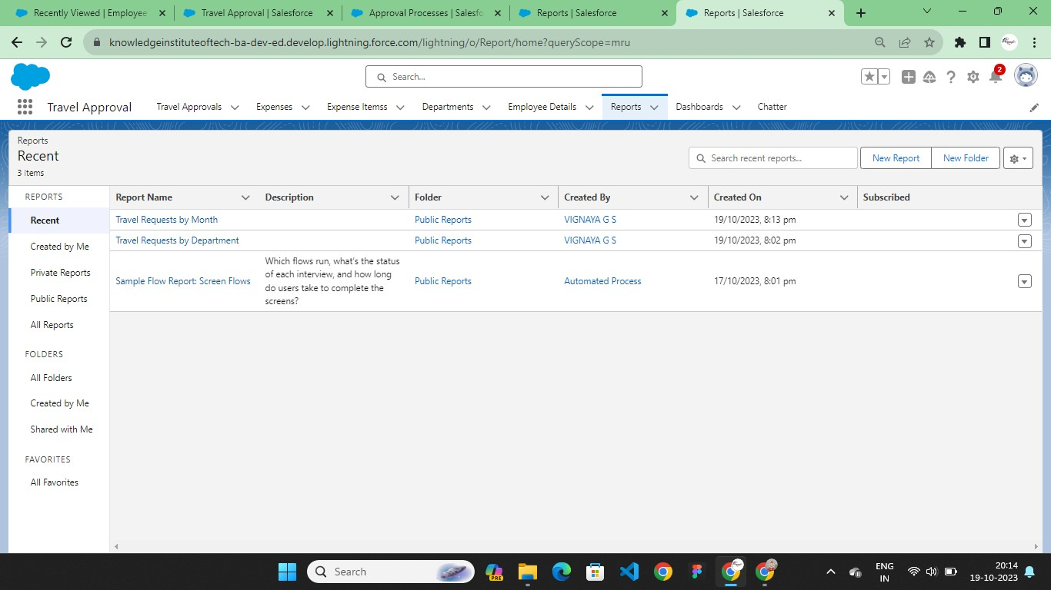

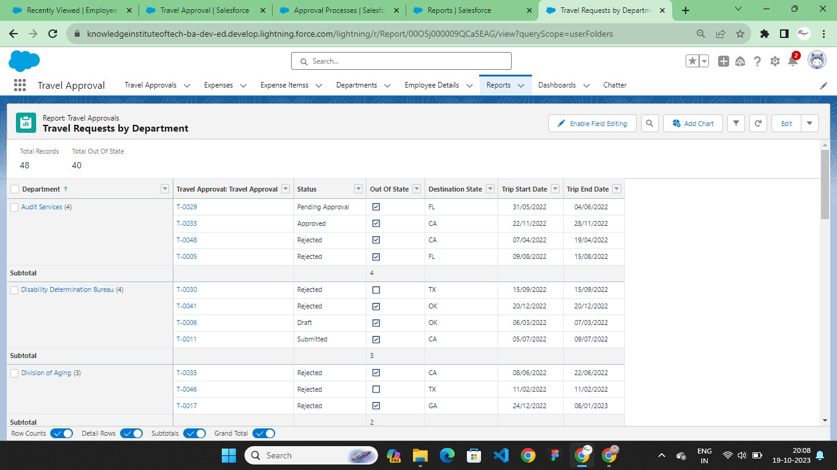

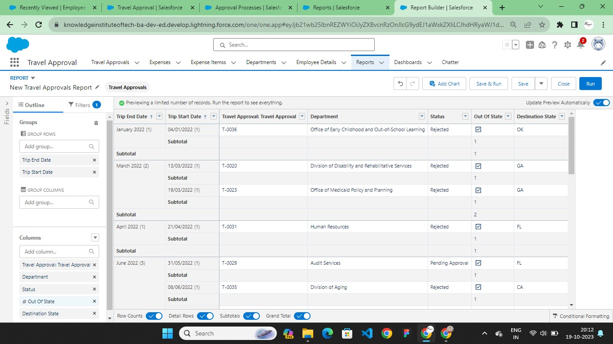

# Dashboard

A dashboard provides an interactive visual display of key metrics and trends. Multiple dashboard components can be shown together on a single dashboard layout, creating rich visual displays of multiple reports that have a common theme.

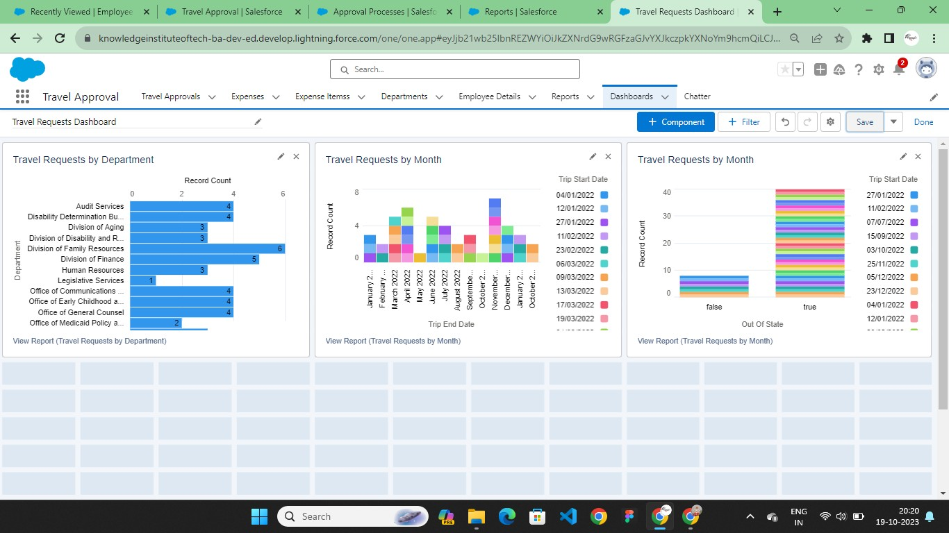

# CHAPTER-6 CONCLUSION

In conclusion, A vehicle management system using Salesforce can help businesses of all sizes to improve the efficiency and effectiveness of their fleet management operations. By providing a centralized platform for managing all aspects of the vehicle lifecycle, Salesforce can help businesses to:

* Reduce costs by streamlining vehicle maintenance and repair processes
* Improve safety by tracking vehicle performance and identifying potential problems
* Increase efficiency by optimizing vehicle utilization and dispatching
* Enhance compliance by ensuring that vehicles are properly registered and insured

In addition to these specific benefits, a vehicle management system using Salesforce can also help businesses to improve their overall customer service and employee satisfaction. By providing a more efficient and effective way to manage their fleet, businesses can free up time and resources to focus on other important priorities.

**Github:**

# CHAPTER-7 PROJECT DEMONSTRATION

<https://github.com/S30HARINI/Naan-Mudhalvan-Salesforces>

**Demo Link:** https://youtu.be/mZV5kdVZYf8?si=YTk6CQHfSlt74xOR